GOVERNMENT OF KHYBER PAKHTUNKHWA IRRIGATION DEPARTMENT



BID SOLICITATION DOCUMENTS
FOR

S. No. | Name of Work/Sub Works | Estimated Cost  in (M) | 2% Earnest  Money in the name of  Executive Engineer Charsadda Irrigation Division  Charsadda (Rs.) | Category/ PEC RelevantCode
1 | Construction/Extension of 1 No Flood protection works along left bank of Swat River near village Babakri PK-65, District Charsadda (ASDI ADP No.1014/251262 during 2025-2026). | 19.90 | 398000/- | Category C-6 & above Spec: Code CE-04
2 | Construction of Road along Water Channel at Ghafoor Killi Tehsil Tangi District Charsadda (ASDI ADP No.1014/251262 during 2025-2026). | 10.00 | 200000/- | Category 6 & above Spec: Code CE-01& CE-04

NAME OF CONTRACTOR:

CHARSADDA IRRIGATION DIVISION, CHARSADDA

February 2026

STANDARD FORM OF BIDDING
DOCUMENTS FOR PROCUREMENT
OF
WORKS (CIVIL WORKS)

(For Smaller Contracts) Under Rs.100 Million

Notified vide Notification No. S.R.O (29)/Vol:1-40/2025-26
Dated Peshawar the August 21, 2025

KHYBER PAKHTUNKHWA PUBLIC PROCUREMENT REGULATORY AUTHORITY (KP-PPRA)

1

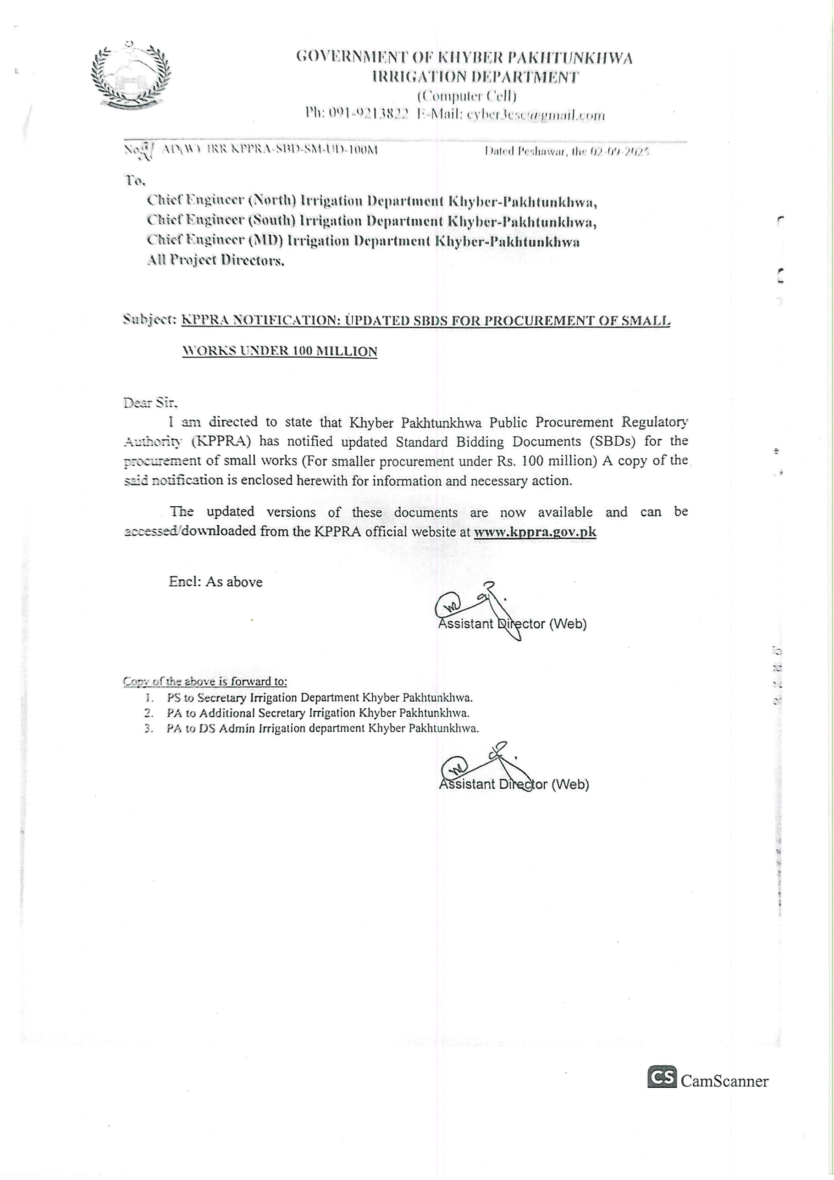

2

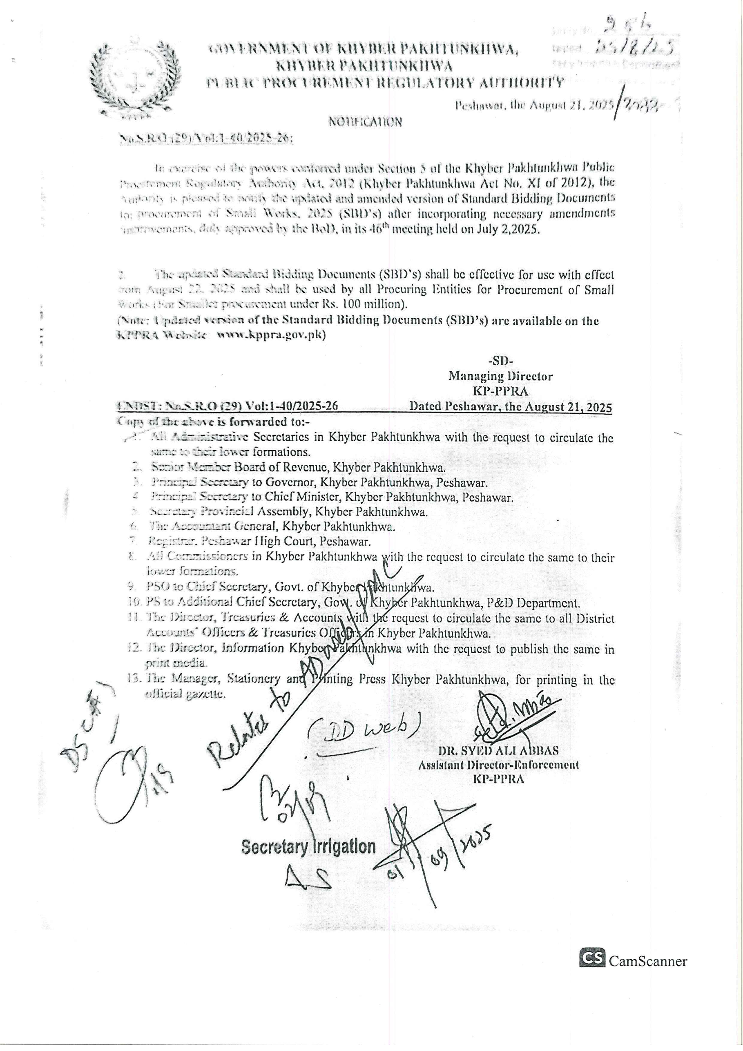

3

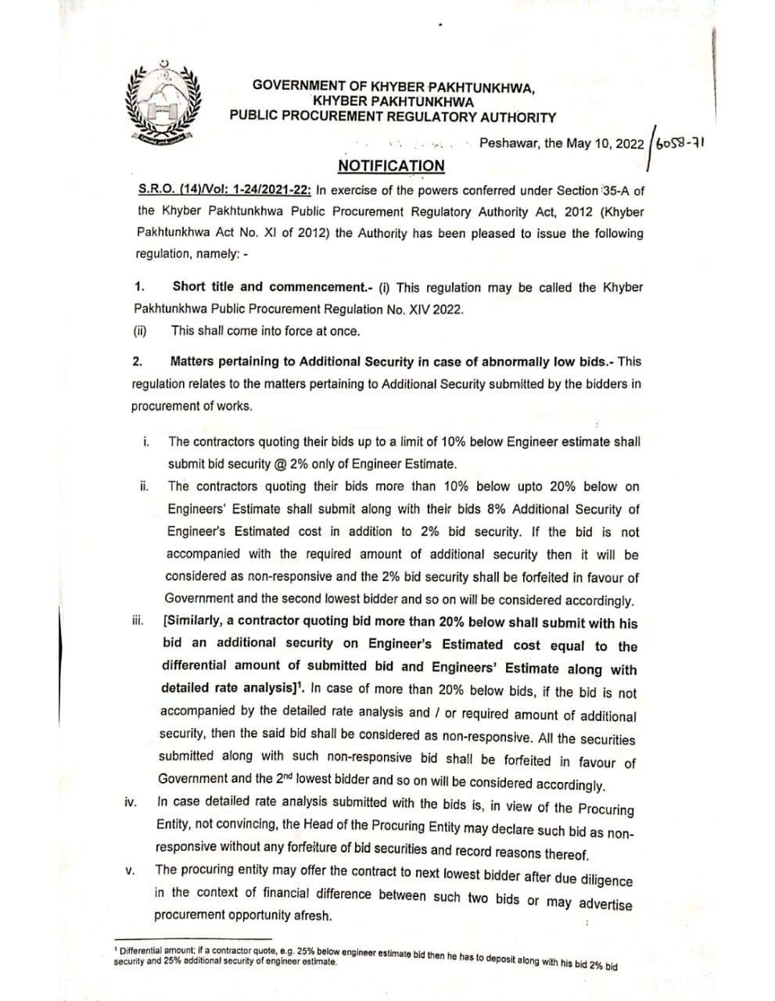

4

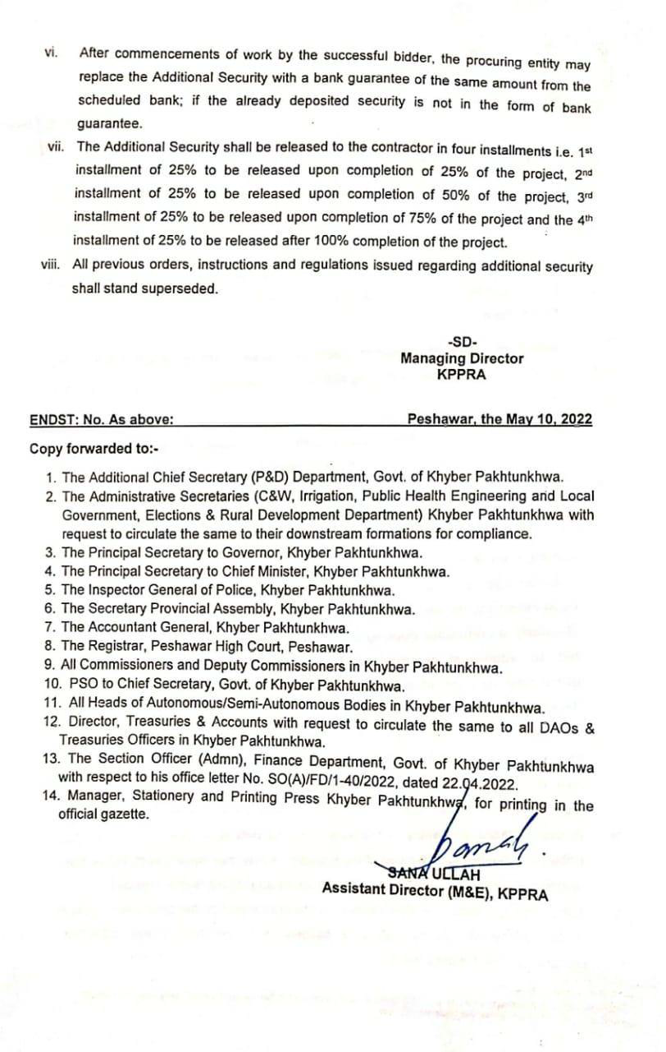

5



6

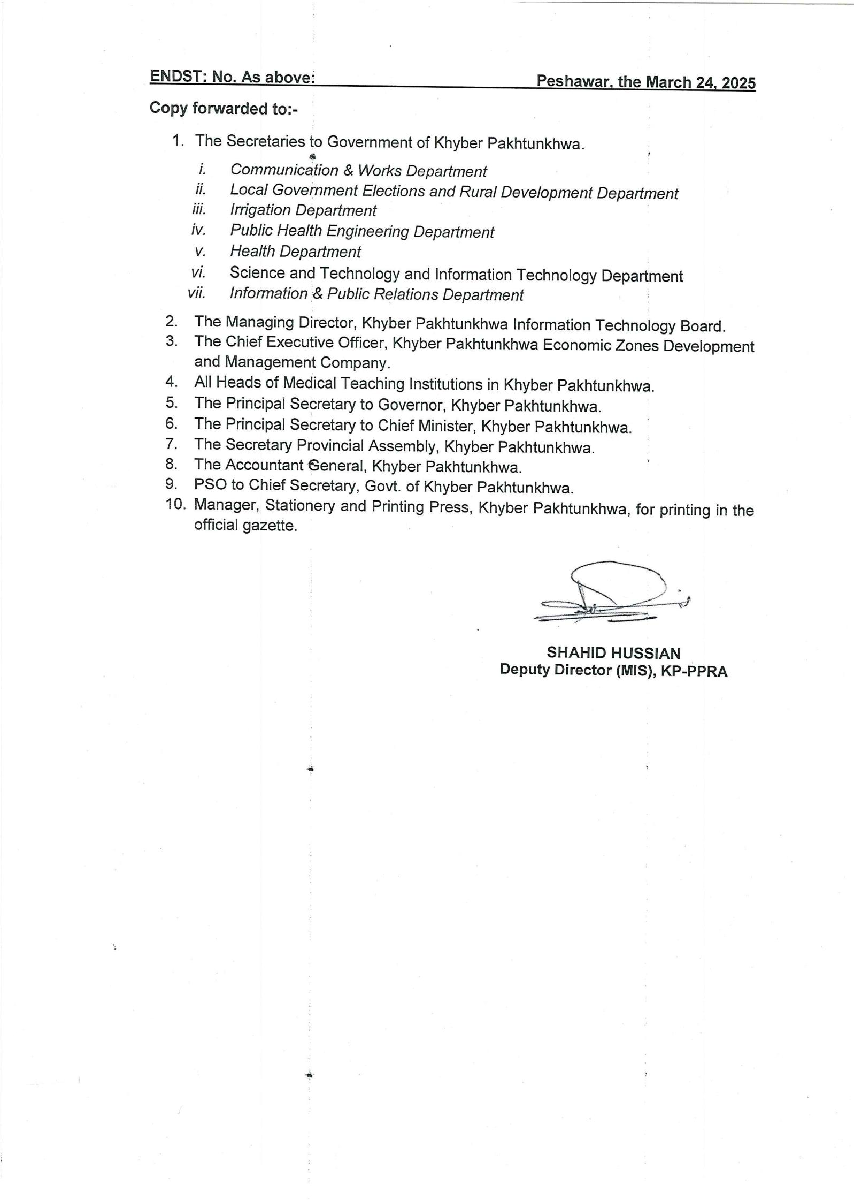

7

P R E F A C E

The Khyber Pakhtunkhwa Standard Bidding Documents (KP-SBDs) have been
prepared, intended to be used by Procuring Entities as defined in the KP Public

Procurement Rules, 2014, and other users according to their requirements. This
document is envisaged for National Competitive Bidding (NCB), and International

Competitive Bidding (ICB), meant for Small Works up to Rs. 100 Million
(constructors registered with PEC and the Procuring Entity having work capacity / limit
of construction cost up to Rs. 100 Million), and may be tailored according to the scope

of work as well as procurement on International Competitive Bidding (ICB) basis
funded by international financial institutions / donors, with payments in foreign
currencies. The users are then to tailor the relevant clauses to suit their requirements
including appropriate modification in the relevant sections of the documents.

The Procuring Entity is expected to manage the contract itself, and the role of an Engineer may be added by the users, if the Procuring Entity wishes to engage a Consultant. The role of an Engineer with specific delegated powers under various clauses of Instructions to Bidders (IB), such as clarifications of bid solicitation documents, amendment of bid solicitation documents, evaluation of bids etc., and to administer the contract under various clauses of Conditions of Contract (CoC)
should | be specified.
This document is harmonized with the KP Public Procurement Rules, 2014, and

Pakistan Engineering Council (PEC) Guidelines
.


This document is prepared under Section 5(b) of the KPPRA Act, 2012, approved by
the Board of Directors of the KP-PPRA, and notified by the KP-PPRA vide its
Notification No. KPPRA/M&E/SBDs/1-1/2015, Dated Peshawar the May 03, 2016.

It is, therefore, mandatory for all procuring entities in the Khyber Pakhtunkhwa to use this
document for procurement of works for smaller contracts/projects up to Rs. 100 Million.
Any suggestions for improvement shall be appreciated. These may be addressed to the Managing Director KPPRA Government of Khyber Pakhtunkhwa Peshawar (e-mail).

8

Subject

SUMMARY OF CONTENTS

Page No

(I)
(II)
(III)
(IV)
(V)
(VI)
(VII)

INVITATION FOR BIDS
INSTRUCTIONS TO BIDDERS & BIDDING DATA
FORM OF BID & SCHEDULES TO BID
CONDITIONS OF CONTRACT & CONTRACT DATA
STANDARD FORMS
SPECIFICATIONS
DRAWINGS

9

07
09
24
38
57
66
67

INVITATION
FOR BIDS

10

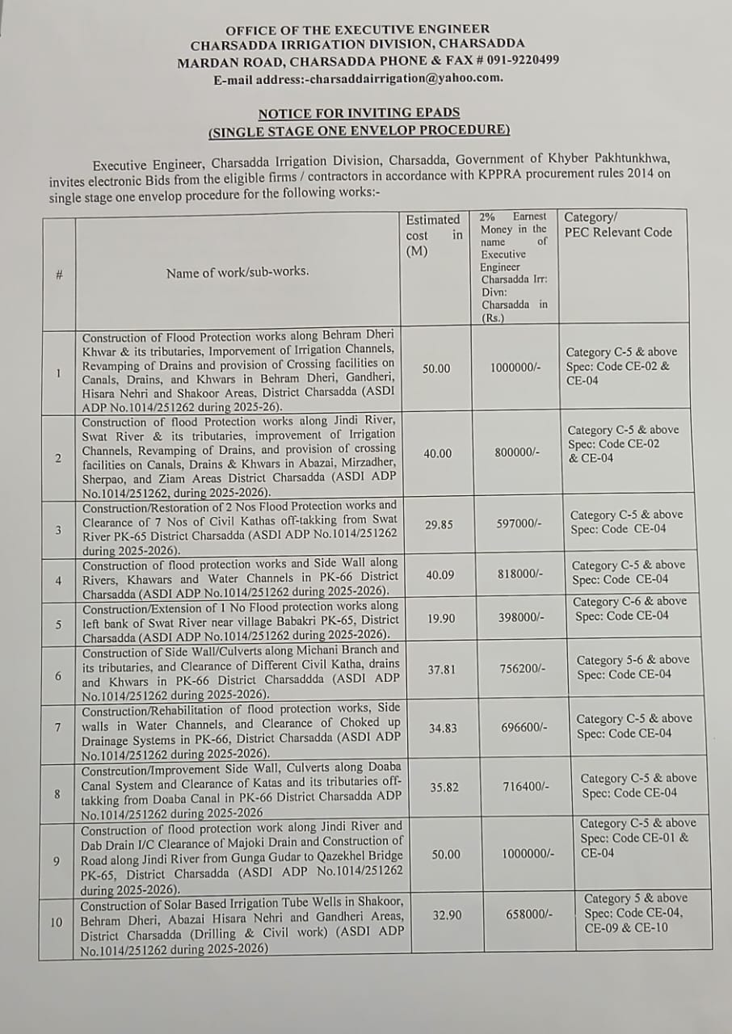
11

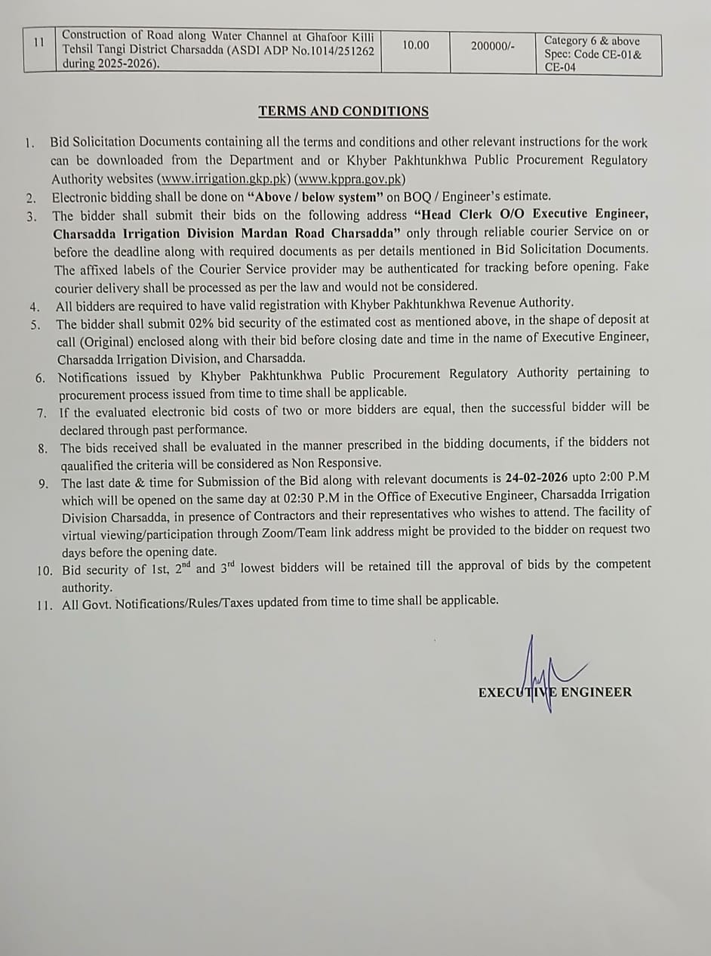

12

NVITATION FOR BIDS

Date:
Bid Reference No.:

1. The Executive Engineer Charsadda Irrigation Division Charsadda procuring officer on behalf of Chief Engineer (Sout) Irrigation Department Peshawar invites sealed bids from eligible bidders
for the Works

[enter title, type and financial volume of work], which will be completed in [enter appropriate
time period] days.

2.

A complete set of Bid Solicitation documents may be obtained by interested bidders on
submission of a written application to the office address given below, and upon payment
of a non-refundable fee of Rs. in shape of Call Deposit Receipt, Demand Draft or
Pay Order, favouring to be issued by a scheduled bank. Bidders may collect the

Bid Solicitation
(Mailing Address).

Documents from the Office of the Procuring Entity, at

3. | All bids must be accompanied by a Bid Security @ 2% of the estimated cost in shape of
 | all Deposit Receipt/Bank Guarantee, issued from the bank account of the bidder, and
 | ust be delivered to _ (Indicate Address and Exact Location) on or before _
ours, on (Date). Bids will be opened at hours on the same day in the presence
f bidders or their representatives, who choose to attend, at the same address [indicate
 | the address if it differs].

4. | The (name of procuring entity) reserves the right to reject all bids or proposals
 | at any time prior to the acceptance of a bid or proposal under Rule 47 of the KP Public
 | Procurement Rules, 2014.

[Note: 1.
2.

The Procuring Entity to enter the requisite information in blank spaces. The bid shall be opened at least thirty minutes after the deadline for submission of bids.]

13

INSTRUCTIONS TO BIDDERS
& BIDDING DATA

14

Clause No.

A. GENERAL

TABLE OF CONTENTS INSTRUCTIONS TO BIDDERS
Description

Page No.
IB.1 IB.2 IB.3

Scope of Bid & Source of Funds Eligible Bidders
Cost of Bidding

11
11
11

B. BIDDING DOCUMENTS
IB.4 IB.5 IB.6

Contents of Bidding Documents Clarification of Bidding Documents Amendment of Bidding Documents

12
12
13

C- PREPARATION OF BID
IB.7 IB.8 IB.9 IB.10
IB.11 IB.12 IB.13 IB.14

Language of Bid
Documents Comprising the Bid
Sufficiency of Bid
Bid Prices, Currency of Bid & Payment
Documents Establishing Bidder’s Eligibility and Qualifications Documents Establishing Works Conformity to Bidding Documents Bidding Security
Validity of Bids, Format, Signing and Submission of Bids.

13
13
14
14
14
14
15
15

D-SUBMISSION OF BID
IB.15

Deadline for Submission, Modification & Withdrawal of Bids.

16

E. BID OPENING AND EVALUATION
IB.16 IB.17

Bid Opening, Clarification and Evaluation Process to be Confidential
(5)

17
19

F. AWARD OF CONTRACT
IB.18 IB.19 IB.20 IB.21 IB.22

Qualification
Award Criteria & Procuring Entity’s Right
Notification of Award & Signing of Contract Agreement Performance Security
Integrity Pact

15

20
20
20
20
20

(Note:

INSTRUCTIONS TO BIDDERS

These Instructions to Bidders (IB) along with Bidding Data will not be part of Contract and will cease to have effect once the Contract is signed).

IB.1

1.1

1.2

IB.2

A.

Scope of Bid & Source of Funds

Scope of Bid

As per title page
Source of Funds

ADP/Provincial Government
Eligible Bidders

GENERAL
2.1

Bidding is opened to all bidders meeting the following requirements:
a) duly valid licensed by the Pakistan Engineering Council (PEC) in the appropriate
category for value of Works & having Specifialization Code (mentioned as per NIT/BSD)

a.1) duly registered with the Khyber Pakhtunkhwa Revenue Authority for the purpose
Sales Tax on Services.

b) duly
Entity.

pre-qualified

(Post-qualification rule 17(1))/enlisted with the Procuring
IB.3
3.1

Cost of Bidding-
The bidder shall bear all costs including bid solicitation documents fee (nominal so as to cover printing/reproduction and mailing costs) and other costs associated with the
preparation and submission of its bid and the Procuring Entity will in no case be
responsible or liable for those costs, regardless of the conduct or outcome of the bidding process.

16

B. BIDDING DOCUMENTS

IB.4 Contents of Bidding Documents
4.1 | In addition to Invitation for Bids, Bid Solicitation Documents are those stated below,
and should be read in conjunction with any Addendum/Corrigendum issued in accordance
with Sub- Clause IB.6.1

1.
2.

Instructions to Bidders & Bidding Data Form of Bid & Schedules to Bid Schedules to Bid comprise the
following:
(i)
(ii)
(iii)
(iv)
(v)
(vi)

Schedule A: Schedule of Prices
Schedule B: Specific Works Data
Schedule C: Works to be Performed by Subcontractors
Schedule D: Proposed Program of Works
Schedule E: Method of Performing Works
Schedule F: Integrity Pact

3.

4.

Conditions of Contract & Contract Data

Standard Forms:
(i) Form of Bid Security
(ii) Form of Performance Security

(iv) Form of Bank Guarantee for Advance Payment (N/A)

5.

Specifications

(As per Bid Solicitation Documents/Notice Inviting EPADS)

6.

Drawings, if any (As per Bid Solicitation Documents/Notice Inviting EPADS)

IB.5

5.1

5.2

Clarification of Bid Solicitation Documents

A prospective bidder requiring any clarification(s) in respect of the Bid Solicitation
Documents may notify the Engineer/Procuring Entity at the Procuring Entity’s/Engineer’s
address indicated in the Bidding Data
.

The Engineer/Procuring Entity will respond to any request for clarification(s), which it
receives earlier than seven (7) days prior to the deadline for the submission of Bids.
Copies of the Engineer’s/Procuring Entity’s response will be forwarded to all
prospective | bidders, | at least five (5) days prior to dead line for submission of Bids, who
have received the Bid Solicitation Documents including a description of the enquiry but
without identifying its source.

17

IB.6 Amendment of Bid Solicitation Documents

At any time prior to the deadline for submission of Bids, the Procuring Entity may, for any reason, whether at its own initiative or in response to a clarification(s) requested by a prospective bidder, modify the Bid Solicitation Documents by issuing
addendum/corrigendum.

6.1

6.2

6.3

Any addendum/corrigendum thus issued shall be part of the Bid Solicitation
Documents pursuant to Sub- Clause 6.1 hereof, and shall be communicated in writing

to all buyers of the Bid Solicitation Documents.
To afford prospective bidders reasonable time in which to take an
addendum/corrigendum into account in preparing their Bids, the Procuring Entity may at
its discretion extend the deadline for submission of Bids.

C. PREPARATION OFBIDS
IB.7 Language of Bid
7.1 The bid prepared by the bidder and all correspondence and documents relating to the Bid, exchanged by the bidder and the Procuring Entity shall be written in the English language, provided that any printed literature furnished by the bidder may be written in another language so long as accompanied by an English translation of its pertinent passages in which case, for purposes of interpretation of the Bid, the English translation shall govern.

IB.8
8.1

Documents Comprising the Bid

The bid prepared by the bidder shall comprise the following components:

(a)

(b)

(c)

(d)

(e)

(f)
(g)

Covering Letter alongwith Single sealed envelope bearing address on the front & back of the envelope of the Procuring Entity and the bidder respectively.

Form of Bid duly filled, signed and sealed, in accordance with Sub- Clause IB.14.3.

Schedules (A to F) to Bid duly filled and initialed, in accordance with the instructions contained therein & in accordance with Sub- ClauseIB14.3.

Bid Security furnished in accordance with Clause IB.13 as well as bid solicitation documents fee as per Clause IB 3.1, & KPPRA Notification No.S.R.O(14)/Vol: 1-24/2021-22 dated Peshawar the 10th May 2022/6058-71 as clarified in the NIT/BSD.
Power of Attorney in accordance with Sub-Clause IB14.5.

Documentary evidence in accordance with Clause IB.11 Documentary evidence in accordance with Clause IB.12.

18

IB.9
9.1

9.2

IB.10
10.1

10.2

10.3

IB.11
11.1

11.2

Sufficiency of Bid
Each bidder shall satisfy himself before bidding as to the correctness and sufficiency of his Bid and of the rates and prices entered in the Schedule of Prices, which rates and prices shall except in so far as it is otherwise expressly provided in the Contract, cover all his obligations under the Contract and all matters and things necessary for the proper completion of the Works.
The bidder is advised to obtain for himself at his own cost and responsibility all information that may be necessary for preparing the bid and entering into a Contract for execution of the Works.

Bid Prices, Currency of Bid and Payment
The bidder shall fill up the Schedule of Prices (Schedule A to Bid) indicating the unit rates and prices of the Works to be performed under the Contract. Unit rate offered for an item shall be considered upto two significant decimal places for evaluation purposes by the Procuring Entity. Prices in the Schedule of Prices shall be entered keeping in view the instructions contained in the Preamble to Schedule of Prices.

Unless otherwise stipulated in the Conditions of Contract, prices quoted by the bidder shall remain fixed during the bidder’s performance of the Contract and not subject to variation on any account.

The unit rates and prices in the Schedule of Prices shall be quoted by the bidder in the currency as stipulated in Bidding Data.

Documents Establishing Bidder’s Eligibility and Qualifications
Pursuant to Clause IB.8, the bidder shall furnish, as part of its bid, documents establishing the bidder’s eligibility to bid and its qualifications to perform the Contract if its bid is accepted.

Bidder/Manufacturer must possess and provide evidence of its capability and the
experience as stipulated in Bidding Data and the Qualification Criteria stipulated in the
Bid Solicitation Documents.

IB.12 Documents Establishing Works’ Conformity to Bidding Documents

12.1

12.2

The documentary evidence of the Works’ conformity to the Bid Solicitation Documents
may be in the form of literature, drawings, and data, and the bidder shall furnish
documentation as set out in Bidding Data.

The bidder shall note that standards for workmanship, material and equipment and references to brand names or catalogue numbers if any, designated by the Procuring Entity/Procuring Officer in the Technical Provisions are intended to be descriptive only and not restrictive if applicable as per Notice Inviting EPADS.

19
IB.13 Bid Security
13.1

13.2

13.3

13.

Each bidder shall furnish, as part of his bid, a Bid Security as stipulated in Bidding Data in the form of Call Deposit Receipt or a Bank Guarantee issued by a Scheduled Bank in Pakistan, in favour of the Procuring Entity/Procuring Officer valid for a period up to twenty eight (28) days beyond the bid validity date. The bid security shall be submitted from the account of the bidder, who submits the bid. Any bid not accompanied by an acceptable Bid Security shall be rejected by the Procuring Entity as non-responsive.

The bid securities of unsuccessful bidders will be returned upon award of contract to the successful bidder or on the expiry of validity of Bid Security whichever is earlier.
[“The bid security of successful bidder be retained with the Procuring Entity till completion of the defect liability period and the amount of guarantee will be reduced by an equivalent amount”.]³
The Bid Security may be forfeited:

(a)

(b)

(c)

if a bidder withdraws his bid during the period of bid validity; or

if a bidder does not accept the correction of his Bid Price, pursuant to Sub-Clause 16.4 (b) hereof; or

in the case of a successful bidder, if he fails to:

(i)

(ii)

furnish the required Performance Security in accordance with Clause IB.21, or

sign the Contract Agreement, in accordance with Sub-Clauses IB.20.2 & 20.3.

IB.14 Validity of Bids, Format, Signing and Submission of Bid

14.1

14.2 14.3

14.4

Bids shall remain valid for the period stipulated in the Bidding Data after the date of bid opening.

All Schedules to Bid are to be properly completed and signed.
No alteration is to be made in the Form of Bid except in filling up the blanks as directed. If any alteration be made or if these instructions be not fully complied with, the bid may be rejected.
Each bidder shall prepare Original and number of copies specified in the Bidding Data
of the documents comprising the bid as described in Clause IB.8 and clearly mark them “ORIGINAL” and “COPY” as appropriate. In the event of discrepancy between them, the

2
3

Inserted by KPPRA Notification No. KPPRA/M&E/Estt:/1-12/2017-18 dated April 05, 2018.
Substituted by KPPRA Notification No. KPPRA/M&E/Estt:/1-4/2016 dated May24, 2016.

20

14.5

14.6

IB.15

15.1

15.2

15.3

15.4

15.5

original shall prevail.

The original and all copies of the bid shall be typed or written in indelible ink and shall be signed by a person or persons duly authorized to sign (in the case of copies, Photostats are also acceptable). This shall be indicated by submitting a written Power of Attorney authorizing the signatory of the bidder to act for and on behalf of the bidder. All pages of the bid shall be initialed and official seal be affixed by the person or persons signing the bid.

The Bid shall be delivered in person, through courier service or sent by registered mail, or as specifically instructed by the Procuring Entity otherwise, at the address to Procuring Entity as given in Bidding Data.

D. SUBMISSION OFBID

Deadline for Submission, Modification & Withdrawal of Bids

Bids must be received by the Procuring Entity at the address provided in Bidding
Data/Notice Inviting EPADS not later than the time and date stipulated therein. In the
event of the specified date for the submission of bids declared a holiday for the
Procuring Entity, the Bids will be received up to the appointed time on the next working
day.

Bids submitted through telegraph, telex, fax or e-mail shall not be considered.

Any bid received by the Procuring Entity after the deadline for submission prescribed in Bidding Data/Notice Inviting EPADS will be returned unopened to such bidder.

Any bidder may modify or withdraw his bid after bid submission provided that the modification or written notice of withdrawal is received by the Procuring Entity prior to the deadline for submission of bids.
Withdrawal of a bid during the interval between the deadline for submission of bids and the expiration of the period of bid validity specified in the Form of Bid may result in forfeiture of the Bid Security pursuant to Sub-Clause IB.13.5 (a).

21

E, BID OPENING AND EVALUATION
IB.16 Bid Opening, Clarification and Evaluation

16.1

16.2

The Procuring Officer/Procuring Entity will open the bids, in the presence of bidders or their representatives, who choose to attend, at the time, date, and venue stipulated in the Bid Solicitation Documents/Notice Inviting EPADS.

The name of the bidder, bid modifications, discounts or withdrawals, presence of bid security or affidavit as the case may be and the total amount of each bid and any alternatives, if so permitted, shall be read out aloud and recorded, and a copy of the record shall be made available to any bidder on request. The Procuring Entity will record the minutes of the bid opening meeting. Bidders or their representatives, who choose to attend the bid opening meeting, shall sign the attendance sheet.To assist in the examination, evaluation and comparison of Bids the Engineer/Procuring Entity may, at its discretion, ask the bidder for a clarification of its Bid. The request for clarification and the response shall be in writing and no change in the price or substance of the Bid shall be sought, offered or permitted.

16.3 (a

) Prior to the detailed evaluation, pursuant to Sub-Clauses IB.16.7 to 16.9, the
Engineer/Procuring Entity will determine the substantial responsiveness of each
bid to the Bid Solicitation Documents. For purpose of these Clauses, a substantially responsive bid is one which conforms to all the terms and conditions of the Bid Solicitation Documents without material deviations. It will include to determine the requirements listed in Bidding Data.

16.4

16.5

16.6

(a)

b) Arithmetical errors will be rectified on the following basis:
(
If the bidder does not accept the corrected amount of Bid, his Bid will be rejected,
and his Bid Security will be forfeited.

A Bid determined as substantially non-responsive will be rejected and will not subsequently be made responsive by the bidder by correction of then on- conformity.
Any minor informality or non-conformity or irregularity in a Bid, which does not
constitute a material deviation may be waived by Procuring Entity, provided such
waiver does not prejudice or affect the relative ranking of other bidders.
The Engineer/Procuring Entity will evaluate and compare only the bids previously determined to be substantially responsive pursuant to Sub-Clauses IB.16.4 to 16.6 as per requirements given hereunder. Bids will be evaluated for complete scope of works. The prices will be compared on the basis of the Evaluated Bid Price pursuant to Sub- Clause
16.7 herein below.
It will be examined in detail whether the Works offered by the bidder complies

22
with the Technical Provisions of the Bid Solicitation Documents.

b) It will be examined in detail whether the bids comply with the
(
commercial/contractual |  | conditions of the Bid Solicitation Docum | ents. It is expected
 | that no material deviation/stipulation shall be taken by the bidders.

16.8

Evaluated Bid Price
In evaluating the bids, the Engineer/Procuring Entity will determine for each bid in addition to the Bid Price, the following factors (adjustments) in the manner and to the extent indicated below to determine the Evaluated Bid Price:

(i)

(ii)

(iii)

(iv)

making any correction for arithmetic errors pursuant to Sub-Clause 16.4 hereof.

making an appropriate price adjustment for any other acceptable variation or deviation.

making an appropriate price adjustment for deviations in terms of Payments (if any and acceptable to the Procuring Entity).

discount, if any, offered by the bidders as also read out and recorded at the time of bid opening.
16.9

Evaluation Methods
Pursuant to Sub-Clause 16.8, Para (ii), and (iii) following evaluation methods for price adjustments will be followed:
(i)

(ii)

(iii)

Price Adjustment for Technical Compliance

The cost of making good any deficiency resulting from technical noncompliance will be added to the Corrected Total Bid Price for comparison purposes only. The adjustments will be applied taking the highest price quoted by other bidders being evaluated in detail in their original Bids for corresponding item. In case of non-availability of price from other bidders, the price will be estimated by the Engineer/Procuring Entity.

Price Adjustment for Commercial Compliance

The cost of making good any deficiency resulting from any quantifiable variations and deviations from the Bid Schedules and Conditions of Contract, as determined by the Engineer/Procuring Entity will be added to the Corrected Total Bid Price for comparison purpose only. Adjustment for commercial compliance will be added to the Corrected Total Bid Prices.
Price Adjustment for Deviation in Terms of Payments Refer to Bidding Data

23
IB.17 Process to be Confidential

17.1

17.2

Subject to Sub-Clause IB.16.3 heretofore, no bidder shall contact Engineer/Procuring Entity on any matter relating to its Bid from the time of the Bid opening to the time the bid evaluation result is announced by the Procuring Entity. The evaluation result shall be announced at least ten (10) days prior to award of Contract. The announcement to all bidders will include table(s) comprising read out prices, discounted prices, price adjustments made, final evaluated prices and recommendations against all the bids evaluated.

Any effort by a bidder to influence Engineer/Procuring Entity in the Bid evaluation, Bid

comparison or Contract Award decisions may result in the rejection of his Bid. A complaint, against any decision, action or omission in the procurement process till the announcement of final results of the bids evaluation under Rule 45 of the KP Public Procurement Rules, 2014 may be made within ten (10) days of making it public in terms of Rule 45 of the Rules ibid. Provided that no complaint shall lie against selection of a procurement method and decision to reject all tenders, quotations or proposals, as specified under the KPPRA Act, 2012, and KP Public Procurement Rules, 2014, respectively.
E. AWARD OF CONTRACT

IB.18. Post Qualification.
18.1

18.2

The Procuring Entity, at any stage of the bid evaluation, having credible reasons for or prima facie evidence of any defect in supplier’s or contractor’s capacities, may require the suppliers or contractors to provide information concerning their professional, technical, financial, legal or managerial competence whether already pre-qualified or not:

Provided that such qualification shall only be laid down after recording reasons therefor in writing. They shall form part of the records of that bid evaluation report.
The determination will take into account the bidder’s financial and technical capabilities. It will be based upon an examination of the documentary evidence of the bidders’ qualifications submitted under Clause IB.11, as well as such other information required in the Bidding Documents.

IB.19 Award Criteria & Procuring Entity’s Right
19.1

19.2

Subject to Sub-Clause IB.19.2, the Procuring Entity will award the Contract to the bidder, whose
bid has been determined to be substantially responsive to the Bid Solicitation Documents, and
who has offered lowest responsive financial bid amongst technically responsive bids, provided
that such bidder has been determined to be qualified to satisfactorily perform the Contract in
accordance with the provisions of Clause IB.18.
Notwithstanding Sub-Clause IB.19.1, the Procuring Entity reserves the right to accept or
reject any bid, and to annul the bidding process and reject all bids, at any time prior to
the acceptance of a bid or proposal under Rule 47(1) of the KP Public Procurement
Rules, 2014, without thereby incurring any liability to the affected bidders or any
obligation to inform the affected bidders of the grounds for the Procuring Entity’s action
except that the grounds for its rejection of all bids shall upon request be communicated,

24

IB.20
20.1

20.2

20.3

IB.21

21.1

21.2

IB.22

to any bidder who submitted a bid, without justification of the grounds. Notice of the
rejection of all the bids shall be given promptly to all the bidders.

Notification of Award & Signing of Contract Agreement
Prior to expiration of the period of bid validity prescribed by the Procuring Entity, the Procuring Entity will notify the successful bidder in writing (“Letter of Acceptance”) that his bid has been accepted.

Within seven (7) days from the date of furnishing of acceptable Performance Security
under | the Conditions of Contract, the Procuring Entity will send the successful bidder
he Form of Contract Agreement provided in the Bid Solicitation Documents,

incorporating |  | all agreements between the parties.

The formal Agreement between the Procuring Entity and the successful bidder shall be executed within seven (7) days of the receipt of Form of Contract Agreement by the successful bidder from the Procuring Entity.

Performance Security

The successful bidder shall furnish to the Procuring Entity a Performance Security in the form and the amount stipulated in the Conditions of Contract within a period of fourteen (14) days after the receipt of Letter of Acceptance.
Failure of the successful bidder to comply with the requirements of Sub-Clauses IB.20.2 & 20.3 or 21.1 or Clause IB.22 shall constitute sufficient grounds for the annulment of the award and forfeiture of the Bid Security

Integrity Pact

The Bidder shall sign and stamp the Form of Integrity Pact provided at Schedule-F to Bid
in the Bid Solicitation Documents for all procurement contracts. Failure to provide such
Integrity Pact shall make the bid non-responsive | .

25

BIDDING DATA

(This section should be filled in by the Engineer/Procuring Entity before issuance of the Bid Solicitation Documents. The following specific data for the Works to be tendered shall complement, amend or supplement the provisions in the Instructions to Bidders. Wherever, there is a conflict, the provisions herein shall prevail over those in the Instructions to Bidders).
Instructions to Bidders
Clause Reference
1.1

Name of Procuring Entity
Executive Engineer, Charsadda Irrigation Division Charsadda (Procuring Officer) on behalf of Superintending Engineer, Peshawar Irrigation Circle, Peshawar.
Brief Description of Works
(As per Notice Inviting EPADS)
5.1

b)

(a)

Procuring Entity’s address:
Office of the Superintending Engineer Peshawar Irrigation Circle, Irrigation Department Warsak Road Kababyan Peshawar
Phone No.091-9212115 Email:sepicpeshawar@gmail.com
Engineer’s address:
Office of the Executive Engineer, Charsadda Irrigation Division Charsadda
Mardan Road District Offices Charsadda.
Phone No.091-9220499 Email:charsaddairrigation@yaoo.com

10.3 Bid shall be quoted entirely in Pak. Rupees (Above/Below) on applicable schedule and non-Schedule items. The payment shall be made in Pak. Rupees for work done on release of funds, subject to fulfillment of Codal formalities, Technical Sanction, Agreement Sanction, complying of Material & Technical specification.

11.2

The bidder/manufacturer has the financial, technical and production capability necessary to perform the Contract i.e Registration with PEC in relevant category & financial limit as noted in Notice Inviting EPADS and Bid Solicitation Documents, Registration with KPPRA, Enlistment with works Department Khyber Pakhtunkhwa, has been issued EPADS Login & password.

26

12.1

(a)

(b)

Essential technical specification as per documents at the following link are Required: https:/www.finance.gkp.pk/attacments/032b21c0a37611cca4c0b55aac984a07/d
ownload (Technical Specification on MRS 2025 Ist Bi Annual)
Essential Material specification as per document at te following link are required: https:/www,finance.gkp.pk/attacments/0332b21c0a37611eca4e0b55aac984a07/d ownload (Material Specification on MRS 2025 Ist Bi Annual)
Complete set of technical information, description data, literature and drawings as required in accordance with Schedule B to Bid, Specific Works Data. This will include but not be limited to a sufficient number of drawings, photographs, catalogues, illustrations and such other information as is necessary to illustrate clearly the significant characteristics such as general construction dimensions and other relevant information about the works to be performed.

13.1

14.1

14.4

14.6

15.1

16.1

Amount of Bid Security
2% of the estimated cost as per Notice Inviting EPADS/BSD in line with the KPPRA Notification
No.S.R.O. (14)/Vol: 1-24/2021-22/6058-71, dated Peshawar, the 10th May 2022.
Period of Bid Validity
90 days

Number of Copies of the Bid to be Submitted

One original
(a) Procuring Entity's Address for the Purpose of Bid Submission
Office of the Executive Engineer, Charsadda Irrigation Division Mardan Road District Offices
Charsadda.
Deadline for Submission of Bids As per Notice Inviting EPADS.

Venue, Time, and Date of Bid Opening As per Notice Inviting EPADS

27

16.4

Responsiveness of Bids
(i)
(ii)
(iii) (iv)

(v)
(vi) (vii)

(viii)

(ix)

the Bid is valid till required period,
the Bid prices are firm during currency of contract (if it is a fixed price bid) completion period offered is within specified limits,
the Bidder/Manufacturer is eligible to Bid and possesses the requisite experience, capability and qualification (As per BSD and Notice Inviting EPADS)
the Bid does not deviate from basic technical requirements and
the Bids are generally in order, etc.
The bidder shall submit the bids in sealed envelopes on or before the deadline (As per Notice Inviting EPADS).
The bidder shall submit their bids through leading/reliable Courier Service providers on or before the deadline alongwith required documents as per Notice Inviting EPADS/BSD. The affixed labels of the Courier Service provider may be authenticated for tracking. Fake Courier affixed labels and delivery shall be processed as per law and would not be considered.
Delays in the Courier delivery, or delivery of a bid to the wrong office or due to any other reason, shall not accepted as an excuse for failure to deliver a bid at the proper place and time. It shall be the bidder’s responsibility to determine the manner in which timely delivery of his bid will be accomplished by a leading/reliable Courier Service provider.

16.9

Price Adjustment:
(iii)

Price Adjustment for Deviations in Terms of Payment
If a bid deviates from the terms of payment/payment conditions as specified in the Conditions of Contract and if such deviation is considered acceptable to the Procuring Entity, mark-up earned for any earlier payments involved in the terms outlined in the Bid as compared to those stipulated in the Conditions of Contract shall be calculated at the mark-up rate per annum (insert rate) and shall be added to the Corrected Total Bid Price for comparison purposes only.

28

FORM OF BID AND SCHEDULES TO BID

29

FORM OF BID
(LETTER OF OFFER)

Bid Reference No.

(Name of Works)
To:

Gentlemen,

1.

2.

3.

4.

5.

6.

7.

Having examined the Bidding Documents including Instructions to Bidders, Bidding Data, Conditions of Contract, Contract Data, Specifications, Drawings, if any, Schedule of Prices and Addenda Nos.
for the execution of the above-named Works,
we, the undersigned, being a company doing business under the name of and address
and being duly incorporated under the laws of Pakistan hereby offer to execute and complete such Works and remedy any defects therein in conformity with the said Documents including Addenda thereto for the Total Bid Price of Rs
(Rupees ) or such
other sum as may be ascertained in accordance with the said Documents.

We understand that all the Schedules attached hereto form part of this Bid.

As security for due performance of the undertakings and obligations of this Bid,
we submit herewith a Bid Security in the amount of
drawn in your favour or made payable to you
and valid for a period of twenty eight (28) days beyond the period of validity of Bid.

We undertake, if our Bid is accepted, to commence the Works and to deliver and complete the Works comprised in the Contract within the time(s) stated in Contract Data.

We agree to abide by this Bid for the period of days from the date
fixed for receiving the same and it shall remain binding upon us and may be accepted at any time before the expiration of that period.

Unless and until a formal Agreement is prepared and executed, this Bid, together with your written acceptance thereof, shall constitute a binding contract between us.

We undertake, if our Bid is accepted, to execute the Performance Security

30

8.

9.

referred to in Conditions of Contract for the due performance of the Contract.

We understand that you are not bound to accept the lowest or any bid you may receive.
We do hereby declare that the Bid is made without any collusion, comparison of figures or arrangement with any other person or persons making a bid for the Works.

Dated this

Signature

day of

, 20

in the capacity of

duly authorized to sign bid for and on behalf of
(Name of Bidder in Block Capitals)

Address

Witness:

(Signature)
Name: Address:

NIC No.

31

(Seal)

_

[SCHEDULES TO BID INCLUDE THE FOLLOWING:


Schedule A to Bid: Schedule of Prices
Schedule B to Bid: Specific Works Data

Schedule C to Bid: Works to be performed by Subcontractors Schedule D to Bid: Proposed Program of Works
Schedule E to Bid: Method of Performing Works
Schedule F to Bid: Integrity Pact]

32

Sr. No.

1.

2.

SCHEDULE – A TO BID

SCHEDULE OF PRICES

Preamble to Schedule of Prices

Schedule of Prices

*(a) Summary of Bid Prices
* (b) Detailed Schedule of Prices

Page No.

29

31

* [To be prepared by the Engineer/Procuring Entity]

33

1.

SCHEDULE - A TO BID

PREAMBLE TO SCHEDULE OF PRICES

General

2.

1.1The Schedule of Prices shall be read in conjunction with the Conditions of Contract, Contract Data together with the Specifications and Drawings, if any.

1.2 The Contract shall be for the whole of the Works as described in these Bidding Documents. Bids must be for the complete scope of works.

Description
2.1

The general directions and descriptions of works and materials are not necessarily repeated nor summarized in the Schedule of Prices. References to the relevant sections of the Bid Solicitation Documents shall be made before entering prices against each item in the Schedule
of Prices.

3. Units & Abbreviations
3.1

Units of measurement, symbols and abbreviations expressed in the Bid
Solicitation Documents shall comply with the System International d’Unites
(SI Units).

(Note: The abbreviations to be used in the Schedule of Prices to be defined by the Procuring Entity).

4.

Rates and Prices

4.1

4.2

4.3

4.4

Except as otherwise expressly provided under the Conditions of Contract, the rates and amounts entered in the Schedule of Prices shall be the rates at which the Contractor shall be paid and shall be the full inclusive value of the works set forth or implied in the Contract; except for the amounts reimbursable, if any to the Contractor under the Contract.

Unless otherwise stipulated in the Contract Data, the rates and prices entered by the bidder shall not be subject to adjustment during the performance of the Contract.

All duties, taxes and other levies payable by the Contractor shall be included in the rates and prices.
The whole cost of complying with the provisions of the Contract shall be included in the items provided in the Schedule of Prices, and where no items are provided, the cost shall be deemed to be distributed

34

SCHEDULE - A TO BID

among the rates and prices entered for the related items of the Works and no separate payment will be made for those items.
The rates, prices and amounts shall be entered against each item in the Schedule of Prices. Any item against which no rate or price is entered by the bidder will not be paid for by the Procuring Entity when
executed and shall be deemed covered by the rates and prices for other items in the Schedule of Prices.
4.5

(a)

*(b)

The bidder shall be deemed to have obtained all information as to and all requirements related thereto which may affect the bid price.
The Contractor shall be responsible to make complete arrangements for the transportation of the Plant to the Site.

4.6

*(Procuring Entity may modify as appropriate)
The Contractor shall provide for all parts of the Works to be completed in every respect. Notwithstanding that any details, accessories, etc. required for the complete installation and satisfactory operation of the Works, are not specifically mentioned in the Specifications, such
details shall be considered as included in the Contract Price.

5.

Bid Prices
5.1Break-up of Bid Prices

The various elements of Bid Prices shall be quoted as detailed by the Procuring Entity in the format of Schedule of Prices.
The bidder shall recognize such elements of the costs which he expects to incur the performance of the Works and shall include all such costs in the rates and amounts entered in the Schedule of Prices.

5.2

Total Bid Price

The total of bid prices in the Schedule of Prices shall be entered in the Summary of Bid Prices.

6.

Provisional Sums
6.1Provisional Sums included and so designated in the Schedule of Prices if any, shall be expended in whole or in part at the direction and discretion of the Engineer/Procuring Entity. The Contractor will only receive payment in respect of Provisional Sums if he has been instructed by the Engineer/Procuring Entity to utilize such sums.

35

SCHEDULE - A TO BID

SCHEDULE OF PRICES – SUMMARY OF BID PRICES

Bill No. | Description | Total Amount (Rs)
1.
 | Total Bid Price (The amount to be entered in Paragraph 1 of the Form of Bid) (In words).

36

SCHEDULE - A TO BID

SCHEDULE OF PRICES

Item No. | Description | Quantity | Unit Rate(Rs) | Total Amount (Rs)
1.
Total (to be carried to Summary of Bid Price)

37

SCHEDULE - B TO BID

*SPECIFIC WORKS DATA

THE CONTRACTOR SHALL FOLLOW MATERIAL SPECIFICATIONS AS PER
https:/www.finance.gkp.pk/attachments/032b21c0a37611eca4c0b55aac984a07/download
(Material Specification on MRS 2025 Ist Bi Annual)

THE CONTRACTOR SHALL FOLLOW TECHNICAL SPECIFICATIONS AS PER: https://www.finance.gkp.pk/attacments/032b21c0a37611eca4e0b55aac984a07/download
(Technical Specification on MRS 2025 Ist Bi Annual)

FOR SCHEDULE ITEMS & INDUSTRY STANDARDS SHALL BE ADOPTED/FOLLOWED FOR NON-SCHEDULE ITEMS.

*(Note: The Procuring Entity shall spell out the information & data required to be filled out by the bidder and to furnish complementary information).

38

SCHEDULE – C TO BID
WORKS TO BE PERFORMED BY SUBCONTRACTORS
The bidder will do the work with his own forces except the work listed below which
he intends to sub-contract.
Items of Works
to be Sub-Contracted

Note:

Name and address of Sub-Contractors

Statement of
similar works previously executed (attach evidence)

1.

2.

3.

No change of Sub-Contractors shall be made by the bidder without prior approval of the Procuring Entity.

The truthfulness and accuracy of the statement as to the experience of Sub- Contractors is guaranteed by the bidder. The Procuring Entity’s judgment shall be final as to the evaluation of the experience of Sub-Contractors submitted by the bidder.

Statement of similar works shall include description, location & value of works, year completed and name & address of the clients.

39

SCHEDULE – D TO BID

PROPOSED PROGRAM OF WORKS
Bidder shall provide a program in a bar-chart showing the sequence of work items by which he proposes to complete the Works of the entire Contract. The program should indicate the sequence of work items and the period of time during which he proposes to complete the Works including the activities like designing, schedule of submittal of drawings, ordering and procurement of materials, manufacturing, delivering, construction of civil works, erection, testing and commissioning of Works to be supplied under the Contract.

40

SCHEDULE – E TO BID
METHOD OF PERFORMING WORKS

The bidder is required to submit a narrative outlining the method of performing the Works. The narrative should indicate in detail and include but not be limited to:

- The sequence and methods in which he proposes to carry out the Works, including the
number of shifts per day and hours per shift, he expects to work.

- A list of all major items of constructional and erectional plant, tools and vehicles
proposed to be used in delivering/carrying out the Works at Site

- The procedure for installation of equipment and transportation of equipment
and materials to the site.

- Organization chart indicating head office & field office personnel involved in management, supervision and engineering of the Works to be done under the Contract.

41

SCHEDULE – F TO BID

(INTEGRITY PACT)

DECLARATION OF FEES, COMMISSION, AND BROKERAGE ETC. PAID IN
WORKS CONTRACTS

Contract No. Contract Value: Contract Title:

Dated
………………………………… [name of the Bidder] hereby declares that it has not obtained
or induced the procurement of any contract, right, interest, privilege or other obligation or benefit from Government of Khyber Pakhtunkhwa or any administrative subdivision or agency thereof or any other entity owned or controlled by Government of Khyber Pakhtunkhwa through any corrupt business practice.
Without limiting the generality of the foregoing, [name of the Bidder] represents and warrants that it has fully declared the brokerage, commission, fees etc. paid or payable to anyone and not given or agreed to give and shall not give or agree to give to anyone within or outside Pakistan either directly or indirectly through any natural or juridical person, including its affiliate, agent, associate, broker, consultant, director, promoter, shareholder, sponsor or subsidiary, any commission, gratification, bribe, finder’s fee or kickback, whether described as consultation fee or otherwise, with the object of obtaining or inducing the procurement of a contract, right, interest, privilege or other obligation or benefit in whatsoever form from Government of Khyber Pakhtunkhwa , except that which has been expressly declared pursuant hereto.

[name of the Bidder] certifies that it has made and will make full disclosure of all agreements and arrangements with all persons in respect of or related to the transaction with GoKP and has not taken any action or will not take any action to circumvent the above declaration, representation or warranty.
[name of the Bidder] accepts full responsibility and strict liability for making any false declaration, not making full disclosure, misrepresenting facts or taking any action likely to defeat the purpose of this declaration, representation and warranty. It agrees that any contract, right, interest, privilege or other obligation or benefit obtained or procured as aforesaid shall, without prejudice to any other rights and remedies available to GoKP under any law, contract or other instrument, be voidable at the option of GoKP.

Notwithstanding any rights and remedies exercised by GoKP in this regard, [name of the Bidder] agrees to indemnify GoKP for any loss or damage incurred by it on account of its corrupt business practices and further pay compensation to GoKP in an amount equivalent to ten time the sum of any commission, gratification, bribe, finder’s fee or kickback given by [name of the Bidder] as aforesaid for the purpose of obtaining or inducing the procurement of any contract, right, interest, privilege or other obligation or benefit in whatsoever form from GoKP.

Name of the Procuring Entity: ………………Name of the Bidder: ………… Signature: …………………… Signature: …………………………
[Seal] (32) [Seal]

42

CONDITIONS OF CONTRACT

43

Clause No.

TABLE OF CONTENTS
CONDITIONS OF CONTRACT

Description

Page No.

1.
2.
3.
4.
5.
6.
7.
8.
9.

General Provisions
The Procuring Entity
Engineer’s/Procuring Entity’s Representatives
The Contractor
Design by Contractor
Procuring Entity’s Risks
Time for Completion
Taking Over
Remedying Defects

40
42
42
43
43
44
45
45
46
10. Variations And Claims
11. Contract Price And Payment 12. Default
13. Risks And Responsibilities 14. Insurance
15. Resolution of Disputes
16. Integrity Pact

46
47
49
50
51
51
52

44

1.

1.1

1.1.1

1.1.2

1.1.3

1.1.4

1.1.5

1.1.6

1.1.7

1.1.8

1.1.9

CONDITIONS OF CONTRACT

GENERAL PROVISIONS

Definitions
In the Contract as defined below, the words and expressions defined shall have the following meanings assigned to them, except where the context requires otherwise:

The Contract

“Contract” means the Contract Agreement and the other documents listed in the Contract Data.
“Specifications” means the document as listed in the Contract Data, including Procuring Entity’s requirements in respect of design to be carried out by the Contractor (if any), and any Variation to such document.

“Drawings” means the Procuring Entity’s drawings of the Works as listed in the Contract Data, and any Variation to such drawings.

Persons
“Procuring Entity” means the person named in the Contract Data and the legal successors in title to this person, but not (except with the consent of the Contractor) any assignee.

“Contractor” means the person named in the Contract Data and the legal successors in title to this person, but not (except with the consent of the Procuring Entity) any assignee.

“Party” means either the Procuring Entity or the Contractor.

Dates, Times and Periods

“Commencement Date” means the date fourteen (14) days after the date the Contract comes into effect or any other date named in the Contract Data.
“Day” means a calendar day

“Time for Completion” means the time for completing the Works as stated in the Contract Data (or as extended under Sub-Clause 7.3), calculated from the Commencement Date.

Money and Payments
1.1.10

“Cost” means all expenditure properly incurred (or to be incurred) by Contractor, whether on or off the Site, including overheads and similar charges

45

the

1.1.11

1.1.12

1.1.13

1.1.14

1.1.14

but does not include any allowance for profit.

Other Definitions
“Contractor’s Equipment” means all machinery, apparatus and other things required for the execution of the Works but does not include Materials or Plant intended to form part of the Works.

“Country ” means the Islamic Republic of Pakistan.

“Province” means Khyber Pakhtunkhwa.

“Procuring Entity’s Risks” means those matters listed in Sub-Clause 6.1.

“Force Majeure” means an event or circumstance which makes performance of a Party’s obligations illegal or impracticable and which is beyond that Party’s reasonable control.

1.1.15 ‘Materials” means things of all kinds (other than Plant) to be supplied and
incorporated in the Works by the Contractor.

1.1.16

1.1.17

1.1.18

1.1.19

1.1.20

1.2

1.3

“Plant” means the machinery and apparatus intended to form or forming part of the Works.
“Site” means the places provided by the Procuring Entity where the Works are to be executed, and any other places specified in the Contract as forming part of the Site.

“Variation” means a change which is instructed by the Engineer/Procuring Entity under Sub-Clause 10.1.
‘Works” means any or all the works whether Supply, Installation, Construction etc. and design (if any) to be performed by the Contractor including temporary works and any variation thereof.

“Engineer” means the person, if any, notified by the Procuring Entity to act as Engineer for the purpose of the Contract and named as such in Contract Data.

Interpretation
Words importing persons or parties shall include firms and organizations. Words importing singular or one gender shall include plural or the other gender where the context requires.

Priority of Documents
The documents forming the Contract are to be taken as mutually explanatory of one another. If an ambiguity or discrepancy is found in the documents, the priority of the documents shall be in accordance with the order as listed in the Contract Data.

46

1.4

1.5

1.6

2.

2.1

2.2

2.3

2.4

3.

3.1

Law
The law of the Contract is the relevant Law of Khyber Pakhtunkhwa Province,

Communications
All Communications related to the Contract shall be in English language.

Statutory Obligations

The Contractor shall comply with the Laws of Islamic Republic of Pakistan and shall give all notices and pay all fees and other charges in respect of the Works.

THE PROCURING ENTITY

Provision of Site

The Procuring Entity shall provide the clear Site, and right of access thereto at the
times stated in the Contract Data.
Permits etc.

The Procuring Entity shall, if requested by the Contractor, assist him in applying for permits, licences or approvals which are required for the Works.

Engineer’s/Procuring Entity’s Instructions
The Contractor shall comply with all instructions given by the Procuring Entity or the Engineer, if notified by the Procuring Entity, in respect of the Works including the suspension of all or part of the Works.

Approvals

No approval or consent or absence of comment by the Engineer/Procuring Entity shall affect the Contractor’s obligations.

ENGINEER’S/PROCURING ENTITY’S REPRESENTATIVES

Authorized Person
The Procuring Entity shall appoint a duly authorized person to act for him and on his behalf for the purposes of this Contract. Such authorized person shall be duly identified in the Contract Data or otherwise notified in writing to the Contractor as soon as he is so appointed. In either case the Procuring Entity shall notify the Contractor, in writing, the precise scope of the authority of such authorized person at the time of his appointment.

47

3.2

4.

4.1

4.2

4.3

4.4

Engineer’s/Procuring Entity’s Representative
The name and address of Engineer’s/Procuring Entity’s Representative is given in Contract Data. However the Contractor shall be notified by the Engineer/Procuring Entity, the delegated duties and authority before the Commencement of Works.

THE CONTRACTOR

General Obligations

The Contractor shall carry out the Works properly and in accordance with the Contract. The Contractor shall provide all supervision, labour, Materials, Plant and Contractor’s Equipment which may be required.

Contractor’s Representative

The Contractor shall appoint a representative at site on full time basis to supervise the execution of work and to receive instructions on behalf of the Contractor but only after obtaining the consent of the Procuring Entity for such appointment which consent shall not be unreasonable withheld by the Procuring Entity. Such authorized representative may be substituted/replaced by the Contractor at any time during the Contract Period but only after obtaining the consent of the Procuring Entity as aforesaid.

Subcontracting

The Contractor shall not subcontract the whole of the Works. The Contractor shall not subcontract any part of the Works without the consent of the Procuring Entity.

Performance Security.

The Contractor shall furnish to the Procuring Entity within fourteen (14) days after receipt of
Letter of Acceptance, a Performance Security in the form, amount, and validity stipulated in
the Conditions of Contract. The Performance Guarantee shall be of an amount not exceeding
10% of the Contract Price prescribed in Bid Solicitation Documents/ Letter of Acceptance. Such
guarantee shall be acceptable in any of the following forms:
(a)
(b)

5.

5.1

bank guarantee from any Scheduled Bank in Pakistan or
bank guarantee from a bank located outside Pakistan duly counter-guaranteed by a
Scheduled Bank in Pakistan.

DESIGN BY CONTRACTOR

Contractor’s Design
The Contractor shall carry out design to the extent specified, as referred to in the Contract Data. The Contractor shall promptly submit to the Engineer/Procuring Entity all designs prepared by him. Within fourteen (14) days of receipt the Engineer/Procuring Entity shall notify any comments or, if the design submitted is not in accordance with the Contract, shall reject it stating the reasons. The Contractor shall not construct any element of the Works designed by him within fourteen (14) days after the design has been submitted to the Engineer/Procuring

48

5.2

6.
6.1

Entity or which has been rejected. Design that has been rejected shall be promptly amended and resubmitted. The Contractor shall resubmit all designs commented on taking these comments into account as necessary.

Responsibility for Design
The Contractor shall remain responsible for his bided design and the design under this Clause, both of which shall be fit for the intended purposes defined in the Contract and he shall also remain responsible for any infringement of any patent or copyright in respect of the same. The Engineer/Procuring Entity shall be responsible for the Specifications and Drawings.

PROCURING ENTITY’S RISKS
The Procuring Entity’s Risks
The Procuring Entity’s Risks are:-

a)

b)

c)

d)

e)

f)

g)

h)

i)

war, hostilities (whether war be declared or not), invasion, act of foreign enemies, within the Country;

rebellion, terrorism, revolution, insurrection, military or usurped power, or civil war, within the Country;
riot, commotion or disorder by persons other than the Contractor’s personnel and other employees including the personnel and employees of Sub- Contractors, affecting the Site and/or the Works;

Ionizing radiations, or contamination by radio-activity from any nuclear fuel, or from any nuclear waste from the combustion of nuclear fuel, radio-active toxic explosive, or other hazardous properties of any explosive nuclear assembly or nuclear component of such an assembly, except to the extent to which the Contractor/Sub-Contractors may be responsible for the use of any radio-active material;

Pressure waves caused by aircraft or other aerial devices travelling at sonic or supersonic speeds;

use or occupation by the Procuring Entity of any part of the Works, except as may be specified in the Contract;
late handing over of sites, anomalies in drawings, late delivery of designs and drawings of any part of the Works by the Procuring Entity’s personnel or by others for whom the Procuring Entity is responsible;
a suspension under Sub-Clause 2.3 unless it is attributable to the Contractor’s failure; and

physical obstructions or physical conditions other than climatic conditions, encountered on the Site during the performance of the Works, for which the

49

7.

7.1

7.2

7.3

7.4

8.

8.1

8.2

Contractor immediately notified to the Procuring Entity and accepted by the Procuring Entity.

TIME FOR COMPLETION

Execution of the Works

The Contractor shall commence the Works on the Commencement Date and shall proceed expeditiously and without delay and shall complete the Works, subject to Sub-Clause 7.3 below, within the Time for Completion.

Program
Within the time stated in the Contract Data, the Contractor shall submit to the Engineer/Procuring Entity a program for the Works in the form stated in the Contract Data.

Extension of Time
The Contractor shall, within such time as may be reasonable under the circumstances, notify the Procuring Entity/Engineer of any event(s) falling within the scope of Sub-Clause 6.1 or 10.3 of these Conditions of Contract and request the Procuring Entity/Engineer for a reasonable extension in the time for the completion of Works. Subject to the aforesaid, the Procuring Entity/Engineer shall determine such reasonable extension in the time for the completion of Works as may be justified in the light of the details/particulars supplied by the Contractor in connection with the such determination by the Procuring Entity/Engineer within such period as may be prescribed by the Procuring Entity/Engineer for the same; and the Procuring Entity shall extend the Time for Completion as determined.

Late Completion
If the Contractor fails to complete the Works within the Time for Completion, the Contractor’s only liability to the Procuring Entity for such failure shall be to pay the amount stated in the Contract Data for each day for which he fails to complete the Works.

TAKING-OVER

Completion

The Contractor may notify the Engineer/Procuring Entity when he considers that the Works are complete.

Taking-Over Notice
Within fourteen (14) days of the receipt of the said notice of completion from the Contractor the Procuring Entity/Engineer shall either takeover the completed Works and issue a Certificate of Completion to that effect or shall notify the Contractor his reasons for not taking-over the Works. While issuing the Certificate

50

9.

9.1

9.2

10.
10.1

10.2

of Completion as aforesaid, the Procuring Entity/Engineer may identify any outstanding items of work which the Contractor shall undertake during the Maintenances Period.

REMEDYING DEFECTS

Remedying Defects
The Contractor shall for a period stated in the Contract Data from the date of issue of the Certificate of Completion carry out, at no cost to the Procuring Entity, repair and rectification work which is necessitated by the earlier execution of poor quality of work or use of below specifications material in the execution of Works and which is so identified by the Procuring Entity/Engineer in writing within the said period. Upon expiry of the said period, and subject to the Contractor’s faithfully performing his aforesaid obligations, the Procuring Entity/Engineer shall issue a Maintenance Certificate whereupon all obligations of the Contractor under this Contract shall come to an end.

Failure to remedy any such defects or complete outstanding work within a reasonable time shall entitle the Procuring Entity to carry out all necessary works at the Contractor’s cost. However, the cost of remedying defects not attributable to the Contractor shall be valued as a Variation.

Uncovering and Testing
The Engineer/Procuring Entity may give instruction as to the uncovering and/or testing of any work. Unless as a result of an uncovering and/or testing it is established that the Contractor’s design, Materials, Plant or workmanship are not in accordance with the Contract, the Contractor shall be paid for such uncovering and/or testing as a Variation in accordance with Sub-Clause 10.2.

VARIATIONS AND CLAIMS
Right to Vary

The Procuring Entity/Engineer may issue Variation Order(s) in writing. where for any reason it has not been possible for the Procuring Entity/Engineer to issue such Variations Order(s), the Contractor may confirm any verbal orders given by the Procuring Entity/Engineer in writing and if the same are not refuted/denied by the Procuring Entity/Engineer within seven (7) days of the receipt of such confirmation the same shall be deemed to be a Variation Orders for the purposes of this Sub- Clause.

Valuation of Variations
Variations shall be valued as follows:

a)

b)

at a lump sum price agreed between the Parties, or

where appropriate, at rates in the Contract, or

51

c)

d)

e)

in the absence of appropriate rates, the rates in the Contract shall be used as the basis for valuation, or failing which

at appropriate new rates, as may be agreed or which the Engineer/Procuring Entity considers appropriate, or
if the Engineer/Procuring Entity so instructs, at day work rates set out in the Contract Data for which the Contractor shall keep records of hours of labour and Contractor’s Equipment, and of Materials, used.

10.3

10.4.

10.5

11.

Early Warning

The Contractor shall notify the Engineer/Procuring Entity in writing as soon as he is aware of any circumstance which may delay or disrupt the Works, or which may give rise to a claim for additional payment.

To the extent of the Contractor’s failure to notify, which results to the Engineer/Procuring Entity being unable to keep all relevant records or not taking steps to minimize any delay, disruption, or Cost, or the value of any Variation, the Contractor’s entitlement to extension of the Time for Completion or additional payment shall be reduced/rejected.

Valuation of Claims

If the Contractor incurs Cost as a result of any of the Procuring Entity’s Risks, the Contractor shall be entitled to the amount of such Cost. If as a result of any Procuring Entity’s Risk, it is necessary to change the Works, this shall be dealt with as a Variation subject to Contractor’s notification for intention of claim to the Engineer/Procuring Entity within fourteen (14) days of the occurrence of cause.

Variation and Claim Procedure

The Contractor shall submit to the Engineer/Procuring Entity an itemized make-up of the value of variations and claims within twenty eight (28) days of the instruction or of the event giving rise to the claim. The Engineer/Procuring Entity shall check and if possible agree the value. In the absence of agreement, the Procuring Entity shall determine the value.

CONTRACT PRICE AND PAYMENT
11.1

(a)

Terms of Payments

The amount due to the Contractor under any Interim Payment Certificate issued by the Engineer pursuant to this Clause, or to any other terms of the Contract, shall, subject to Clause 7.4 of Conditions of Contract (CoC) be paid by the Procuring Entity to the Contractor within 30 days after such Interim Payment Certificate has been jointly verified by Procuring Entity and Contractor, or, in the case of the Final Certificate referred to in Sub Clause 11.5 of CoC, within 60 days after such Final

52

(b)

Payment Certificate has been jointly verified by Procuring Entity and Contractor; Provided that the Interim Payment shall be caused in 42 days and Final Payment in 60 days in case of foreign funded project. In the event of the failure of the Procuring Entity to make payment within the times stated, the Procuring Entity shall pay to the Contractor compensation at the 28 days rate of KIBOR+2% per annum in local currency and LIBOR+1% for foreign currency, upon all sums unpaid from the date by which the same should have been paid. The provisions of this Sub-Clause are without prejudice to the Contractor’s entitlement under Clause 12.2 CoC.

Valuation of the Works

The Works shall be valued as provided for in the Contract Data, subject to Clause 10.
11.2

Monthly Statements
The Contractor shall be entitled to be paid at monthly intervals:

a)

b)

the value of the Works executed; and

The percentage of the value of Materials and Plant reasonably delivered to the Site, as stated in the Contract Data, subject to any additions or deductions which may be due.

11.3

11.4

11.5

The Contractor shall submit each month to the Engineer/Procuring Entity a statement showing the amounts to which he considers himself entitled.

Interim Payments

Within a period not exceeding seven (7) days from the date of submission of a statement for interim payment by the Contractor, the Engineer / Procuring Entity shall verify the same and within a period not exceeding thirty (30) days from the said date of submission by the Contractor, the Procuring Entity shall pay to the Contractor the sum verified by the Engineer less retention money at the rate stated in the Contract Data.

Retention
Retention money shall be paid by the Procuring Entity to the Contractor within fourteen (14) days after either the expiry of the period stated in the Contract Data, or the remedying of notified defects, or the completion of outstanding work, all as referred to in Sub-Clause 9.1, whichever is the later.

Final Payment
Within twenty one (21) days from the date of issuance of the Maintenance Certificate the Contractor shall submit a final account to the Engineer to verify and the Engineer shall verify the same within fourteen (14) days from the date of

53

11.6

12.
12.1

12.2

12.3

submission and forward the same to the Procuring Entity together with any documentation reasonably required to enable the Procuring Entity to ascertain the final contract value.

Within sixty (60) days from the date of receipt of the verified final account from the Engineer, the Procuring Entity shall pay to the Contractor any amount due to the Contractor. While making such payment the Procuring Entity may, for reasons to be given to the Contractor in writing, withhold any part or parts of the verified amount.
Currency
Payment shall be in the currency stated in the Contract Data.
DEFAULT
Default by Contractor
If the Contractor abandons the Works, refuses or fails to comply with a valid instruction of the Engineer/Procuring Entity or fails to proceed expeditiously and without delay, or is, despite a written complaint, in breach of the Contract, the Procuring Entity may give notice referring to this Sub-Clause and stating the default.

If the Contractor has not taken all practicable steps to remedy the default within fourteen (14) days after receipt of the Procuring Entity’s notice, the Procuring Entity may by a second notice given within a further twenty one (21) days, terminate the Contract. The Contractor shall then demobilize from the Site leaving behind any Contractor’s Equipment which the Procuring Entity instructs, in the second notice, to be used for the completion of the Works at the risk and cost of the Contractor.

Default by Procuring Entity
If the Procuring Entity fails to pay in accordance with the Contract, or is, despite a written complaint, in breach of the Contract, the Contractor may give notice referring to this Sub-Clause and stating the default. If the default is not remedied within fourteen (14) days after the Procuring Entity’s receipt of this notice, the Contractor may suspend the execution of all or parts of the Works.

If the default is not remedied within twenty eight (28) days after the Procuring Entity’s receipt of the Contractor’s notice, the Contractor may by a second notice given within a further twenty one (21) days, terminate the Contract. The Contractor shall then demobilize from the Site.

Insolvency

If a Party is declared insolvent under any applicable law, the other Party may by notice terminate the Contract immediately. The Contractor shall then demobilize from the Site leaving behind, in the case of the Contractor’s insolvency, any Contractor’s Equipment which the Procuring Entity instructs in the notice is to be

54

12.4

used for the completion of the Works.

Payment upon Termination

After termination, the Contractor shall be entitled to payment of the unpaid balance of the value of the Works executed and of the Materials and Plant reasonably delivered to the Site, adjusted by the following:
a)
b)
c)

d)

any sums to which the Contractor is entitled under Sub-Clause10.4,
any sums to which the Procuring Entity is entitled,
if the Procuring Entity has terminated under Sub-Clause 12.1 or 12.3, the Procuring Entity shall be entitled to a sum equivalent to twenty percent (20%) of the value of parts of the Works not executed at the date of the termination, and
if the Contractor has terminated under Sub-Clause 12.2 or 12.3, the Contractor shall be entitled to the cost of his demobilization together with a sum equivalent to ten percent (10%) of the value of parts of the Works not executed at the date of termination.

13.

13.1

13.2

The net balance due shall be paid or repaid within twenty eight (28) days of the notice of termination.

RISKS ANDRESPONSIBILITIES

Contractor’s Care of the Works

Subject to Sub-Clause 9.1, the Contractor shall take full responsibility for the care of the Works from the Commencement Date until the date of the Procuring Entity’s/Engineer’s issuance of Certificate of Completion under Sub-Clause 8.2. Responsibility shall then pass to the Procuring Entity. If any loss or damage happens to the Works during the above period, the Contractor shall rectify such loss or damage so that the Works conform with the Contract.

Unless the loss or damage happens as a result of any of the Procuring Entity’s Risks, the Contractor shall indemnify the Procuring Entity, or his agents against all claims loss, damage and expense arising out of the Works.

Force Majeure
If Force Majeure occurs, the Contractor shall notify the Engineer/Procuring Entity immediately. If necessary, the Contractor may suspend the execution of the Works and, to the extent agreed with the Procuring Entity demobilize the Contractor’s Equipment.

If the event continues for a period of eighty four (84) days, either Party may then give notice of termination which shall take effect twenty eight (28) days after the giving of the notice.

After termination, the Contractor shall be entitled to payment of the unpaid

55

balance of the value of the Works executed and of the Materials and Plant reasonably delivered to the Site, adjusted by the following:
a)

b)

c)

any sums to which the Contractor is entitled under Sub-Clause10.4,

the cost of his demobilization, and

less any sums to which the Procuring Entity is entitled.

14.

14.1

14.2

15.

15.1

The net balance due shall be paid or repaid within thirty five (35) days of the notice of termination.

INSURANCE

Arrangements

The Contractor shall, prior to commencing the Works, effect insurances of the types, in the amounts and naming as insured the persons stipulated in the Contract Data except for items (a) to (e) and (i) of the Procuring Entity’s Risks under Sub- Clause 6.1. The policies shall be issued by insurers and in terms approved by the Procuring
Entity. The Contractor shall provide the Engineer/Procuring Entity with evidence that any required policy is in force and that the premiums have been paid.

Default
If the Contractor fails to effect or keep in force any of the insurances referred to in the previous Sub-Clause, or fails to provide satisfactory evidence, policies or receipts, the Procuring Entity may, without prejudice to any other right or remedy, effect insurance for the cover relevant to such as a default and pay the premiums due and recover the same plus a sum in percentage given in Contractor Data from any other amounts due to the Contractor.

RESOLUTION OFDISPUTES

Engineer’s Decision
If a dispute of any kind whatsoever arises between the Procuring Entity and the Contractor in connection with the Works, the matter in dispute shall, in the first place, be referred in writing to the Engineer, with a copy to the other party. Such reference shall state that it is made pursuant to this Clause. No later than the twenty eight (28) days after the day on which he received such reference, the Engineer shall give notice of his decision to the Procuring Entity and the Contractor. Unless the Contract has already been repudiated or terminated, the Contractor shall, in every case, continue to proceed with the Work with all due diligence, and the Contractor and the Procuring Entity shall give effect forthwith to every such decision of the Engineer unless and until the same shall be revised, as hereinafter provided in an arbitral award.

56

15.2

15.3

15.4

16

16.1

Notice of Dissatisfaction
If a Party is dissatisfied with the decision of the Engineer or if no decision is given within the time set out in Sub-Clause 15.1 here above, the Party may give notice of dissatisfaction referring to this Sub-Clause within fourteen (14) days of receipt of the decision or the expiry of the time for the decision. If no notice of dissatisfaction is given within the specified time, the decision shall be final and binding on the Parties. If notice of dissatisfaction is given within the specified time, the decision shall be binding on the Parties who shall give effect to it without delay unless and until the decision of the Engineer is revised by an arbitrator.

Arbitration
A dispute which has been the subject of a notice of dissatisfaction shall be finally settled as per provisions of Arbitration Act 1940 (Act No. X of 1940) and Rules made thereunder and any statutory modifications thereto. Any hearing shall be held at the place specified in the Contract Data and in the language referred to in Sub- Clause 1.5.

Resolution of Dispute in Absence of the Engineer.

In case no Engineer has been appointed, the dispute, if any, between the Procuring Entity and the Contractor in connection with the Works, shall first be tried to be resolved amicably. In case the dispute could not be resolved amicably, it shall be settled as per provision of Arbitration Act-1940.

INTEGRITY PACT

If the Contractor, or any of his Sub-Contractors, agents or servants is found to have violated or involved in violation of the Integrity Pact signed by the Contractor as Schedule-F to his Bid, then the Procuring Entity shall be entitled to:

(a)

(b)

(c)

recover from the Contractor an amount equivalent to ten times the sum of any commission, gratification, bribe, finder’s fee or kickback given by the Contractor or any of his Sub-Contractors, agents or servants;

terminate the Contract; and

recover from the Contractor any loss or damage to the Procuring Entity as a result of such termination or of any other corrupt business practices of the Contractor or any of his Sub-Contractors, agents or servants.

On termination of the Contract under Sub-Para (b) of this Sub-Clause, the Contractor shall demobilize from the Site leaving behind Contractor’s Equipment which the Procuring Entity instructs, in the termination notice, to be used for the completion of the Works at the risk and cost of the Contractor. Payment upon such termination shall be made under Sub-Clause 12.4, in accordance with Sub-Para (c) thereof, after having deducted the amounts due to the Procuring Entity under Sub-Para (a) and (c) of this Sub-Clause.

57

(

CONTRACT DATA

Note: Except where otherwise indicated, all Contract Data should be filled in by the
Procuring Entity prior to issuance of the Bid Solicitation Documents)

Sub-Clauses of Conditions of Contract
1.1.3

1.1.4

1.1.5

1.1.7

1.1.9

Procuring Entity’s Drawings, if any As per PC-I and T.S.

The Procuring Entity means
Executive Engineer, Charsadda Irrigation Division Charsadda (Procuring Officer) on behalf of Superintending Engineer Peshawar Irrigation Circle, Peshawar.
The Contractor means
MS ________________________________________Govt: Contractor.

Commencement Date means the date of issue of Engineer’s Notice to Commence which
shall be issued within fourteen (14) days of the signing of the Contract Agreement.

Time for Completion As per PC-I Phasing (Subject to availability of fund)
1.1.20 Engineer (if appointed)

Executive Engineer, Charsadda Irrigation Division Charsadda.

1.3
(a)
(b)
(c)
(d)
(e)
(f)
(g)
(h)

Documents forming the Contract listed in the order of priority:
The Contract Agreement
Letter of Acceptance
The completed Form of Bid
Contract Data
Conditions of Contract
The completed Schedules to Bid including Schedule of Prices The Drawings, if any
The Specifications

(The Procuring Entity may add, in order of priority, such other documents as form part of the Contract. Delete the document, if not applicable)

2.1

3.1

Provision of Site: On the Commencement Date by the Sub-Divisional Officer (Concerned)
Authorized person :Executive Engineer, Charsadda Irrigation Division Carsadda.

58

3.2

4.4

5.1

7.2

Name and address of Engineer’s/Procuring Entity’s representative Executive Engineer, Charsadda Irrigation Division, Charsadda on behalf of Superintending Engineer, Peshawar Irrigation Circle, Peshawar.
Performance Security:
As per KPPRA Act/Rul | es (Latest)

Requirements for Contractor’s design (if any):
Specification Clause No’s ----NIL-----
Program:
Time for submission: Within fourteen (14) days* of the Commencement Date.
Form of program:

(Bar Chart/CPM/PERT or other)
7.4

Amount payable due to failure to complete shall be
(10%) * of sum stated in the Letter of Acceptance

% per day up to a maximum of

9.1

(Usually the liquidated damages are set between 0.05 percent and 0.10 percent per day.)

Period for remedying defects
90 days after measurement date.

10.2

11.1

(e)

*(a)

Variation procedure: As per work progress and site situation

Terms of Payments: As per work done & availability of fund
Payment of Contract Price shall be made in the following manners:

Payment of Contract Price shall be made in the following manner:
i)

10-15% of Contract Price shall be paid as interest free mobilization advance within
days after the receipt of acceptable Bank Guarantee for such advance payment. The
recovery / adjustment of mobilization advance or other advances, if any, is to be affected @ 10-
15% of each IPC, starting from the Ist IPC of the executed works. Full recovery of advances, if
remains un-accounted for in the IPC’s, is to be affected in the final payment certificate.

ii)

80-85% shall be paid in accordance with Clause 8.2,11.2 & 11.3 of Conditions of Contract.
And
iii)

Five percent (5%) shall be paid in accordance with Clause 11.4 of Conditions of
Contract.11.1

59

*(b) Valuation of the Works*:

i)

Lump sum price

(details), or
ii)

Lump sum price with schedules of rates

(details), or
iii) Lump sum price with bill of quantities

(details), or
iv) Re-measurement with estimated/bid quantities in the Schedule of
Prices (details), or/and

v)

Cost reimbursable

(details)

11.2

(b)

Percentage of value of Materials and Plant( for day work if applicable)
Materials
Plant

eighty (80%)*
ninety (90%)*
11.3

11.6

14.1

Percentage of retention: Eight (08%)

Currency of payment: Pak. Rupees

Insurances: (Not applicable)

Type of cover

The Works

Amount of cover

The sum stated in the Letter of Acceptance plus fifteen percent (15%)
Type of cover
Contractor’s Equipment:
Amount of cover
Full replacement cost

* (Procuring Entity to amend as appropriate)

60

14.2

Type of cover
Third Party-injury to persons and damage to property
Rs.200000/-
(The minimum amount of third party insurance should be assessed by the Procuring Officer/Procuring Entity and entered).
Workers: Rs.200000
Other cover*:

(In each case name of insured is Contractor and Procuring Officer/Procuring Entity)
Amount to be recovered (Not applicable)
Premium plus percent ( %).

15.3 Arbitration
Place of Arbitration: The Grievance redressal mechanism as per KPPRA shall
be applicable, only and place shall be Peshawar, Khyber Pakhtunkhwa

* (Procuring Entity to specify as appropriate)

61

STANDARD FORMS

(Note: Standard Forms provided in this document for securities are to be issued by a bank. In case the bidder chooses to issue a bond for accompanying his bid or performance of contract or receipt of advance, the relevant format shall be tailored accordingly without changing the spirit of the Forms of securities).

62

FORM OF BID SECURITY (Bank Guarantee)
Guarantee No.
Executed on
(Letter by the Guarantor to the Procuring Entity)

Name of Guarantor (Scheduled Bank in Pakistan) with
address:
Name of Principal (Bidder) with
address:
Penal Sum of Security (express in words and
figures):
Bid Reference No. Date of Bid _
KNOW ALL MEN BY THESE PRESENTS, that in pursuance of the terms of the Bid and at the request of the said Principal, we the Guarantor above-named are held and firmly bound unto the , (hereinafter called The “Procuring
Entity”) in the sum stated above, for the payment of which sum well and truly to be made, we bind ourselves, our heirs, executors, administrators and successors, jointly and severally, firmly by these presents.

THE CONDITION OF THIS OBLIGATION IS SUCH, that whereas the Principal has submitted the accompanying Bid numbered and dated as above for
(Particulars of Bid) to the said Procuring
Entity; and

WHEREAS, the Procuring Entity has required as a condition for considering the said Bid that the Principal furnishes a Bid Security in the above said sum to the Procuring Entity, conditioned as under:

(1)
(2)

that the Bid Security shall remain valid for a period of twenty eight (28) days beyond the period of validity of the bid;
that in the event of;

(a)
(b)

(c)

the Principal withdraws his Bid during the period of validity of Bid, or
the Principal does not accept the correction of his Bid Price, pursuant to Sub- Clause 16.4 (b) of Instructions to Bidders, or
failure of the successful bidder to

(i)

furnish the required Performance Security, in accordance with Sub- Clause IB-21.1 of Instructions to Bidders, or
(ii) sign the proposed Contract Agreement, in accordance with Sub-
Clauses IB-20.2 & 20.3 of Instructions to Bidders,
the entire sum be paid immediately to the said Procuring Entity for delayed
completion and not as penalty for the successful bidder's failure to perform.

63

NOW THEREFORE, if the successful bidder shall, within the period specified therefore, on the prescribed form presented to him for signature enter into a formal Contract Agreement with the said Procuring Entity in accordance with his Bid as accepted and furnish within fourteen
(14) days of receipt of Letter of Acceptance, a Performance Security with good and sufficient surety , as may be required, upon the form prescribed by the said Procuring Entity for the faithful performance and proper fulfilment of the said Contract or in the event of non- withdrawal of the said Bid within the time specified then this obligation shall be void and of no effect, but otherwise to remain in full force and effect.

PROVIDED THAT the Guarantor shall forthwith pay to the Procuring Entity the said sum stated above upon first written demand of the Procuring Entity without cavil or argument and without requiring the Procuring Entity to prove or to show grounds or reasons for such demand, notice of which shall be sent by the Procuring Entity by registered post duly addressed to the Guarantor at its address given above.

PROVIDED ALSO THAT the Procuring Entity shall be the sole and final judge for deciding whether the Principal has duly performed his obligations to sign the Contract Agreement and to furnish the requisite Performance Security within the time stated above, or has defaulted in fulfilling said requirements and the Guarantor shall pay without objection the sum stated above upon first written demand from the Procuring Entity forthwith and without any reference to the Principal or any other person.

IN WITNESS WHEREOF, the above bounded Guarantor has executed the instrument under its seal on the date indicated above, the name and seal of the Guarantor being hereto affixed and these presents duly signed by its undersigned representative pursuant to authority of its governing body.

Guarantor (Bank)
Witness:

1.

Corporate Secretary (Seal)

2.

1.Signature

2.Name _

3.Title

_

_

_

_

(Name, Title & Address)

Corporate Guarantor (Seal)

64

FORM OF PERFORMANCE SECURITY (Bank Guarantee)

Guarantee No.
Executed on
(Letter by the Guarantor to the Procuring Entity)

Name of Guarantor (Scheduled Bank in Pakistan) with address:
Name of Principal (Contractor)with
address:

Penal Sum of Security (express in words and
figures)

Letter of Acceptance No. Dated

KNOW ALL MEN BY THESE PRESENTS, that in pursuance of the terms of the Bidding Documents and above said Letter of Acceptance (hereinafter called the Documents) and at the request of the said Principal we, the Guarantor above named, are held and firmly bound unto the (hereinafter called the
Procuring Entity) in the penal sum of the amount stated above, for the payment of which sum well and truly to be made to the said Procuring Entity, we bind ourselves, our heirs, executors, administrators and successors, jointly and severally, firmly by thesepresents.

THE CONDITION OF THIS OBLIGATION IS SUCH, that whereas the Principal has accepted the Procuring Entity's above said Letter of Acceptance for
(Name of Contract) for the
(Name of Project).

NOW THEREFORE, if the Principal (Contractor) shall well and truly perform and fulfill all the undertakings, covenants, terms and conditions of the said Documents during the original terms of the said Documents and any extensions thereof that may be granted by the Procuring Entity, with or without notice to the Guarantor, which notice is, hereby, waived and shall also well and truly perform and fulfill all the undertakings, covenants terms and conditions of the Contract and of any and all modifications of the said Documents that may hereafter be made, notice of which modifications to the Guarantor being hereby waived, then, this obligation to be void; otherwise to remain in full force and virtue till all requirements of Clause 9, Remedying Defects, of Conditions of Contract are fulfilled.

Our total liability under this Guarantee is limited to the sum stated above and it is a condition of any liability attaching to us under this Guarantee that the claim for payment in writing shall be received by us within the validity period of this Guarantee, failing which we shall be discharged of our liability, if any, under this Guarantee.

65

We, (the Guarantor), waiving all objections and
defences under the Contract, do hereby irrevocably and independently guarantee to pay to the Procuring Entity without delay upon the Procuring Entity's first written demand without cavil or arguments and without requiring the Procuring Entity to prove or to show grounds or reasons for such demand any sum or sums up to the amount stated above, against the Procuring Entity's written declaration that the Principal has refused or failed to perform the obligations under the Contract, for which payment will be effected by the Guarantor to Procuring Entity’s designated Bank & Account Number.

PROVIDED ALSO THAT the Procuring Entity shall be the sole and final judge for deciding whether the Principal (Contractor) has duly performed his obligations under the Contract or has defaulted in fulfilling said obligations and the Guarantor shall pay without objection any sum or sums up to the amount stated above upon first written demand from the Procuring Entity forthwith and without any reference to the Principal or any other person.

IN WITNESS WHEREOF, the above bounded Guarantor has executed this Instrument under its seal on the date indicated above, the name and corporate seal of the Guarantor being hereto affixed and these presents duly signed by its undersigned representative, pursuant to authority of its governing body.

Guarantor (Bank)
Witness:
1. _

Corporate Secretary (Seal)

2.

(Name, Title & Address)

1. Signature _
2. Name _

3. Title

Corporate Guarantor (Seal)

66

_

_

FORM OF CONTRACT AGREEMENT

THIS CONTRACT AGREEMENT (hereinafter called the “Agreement”) made on the
day of 200 _ between (hereinafter called
the “Procuring Entity”) of the one p a r t and (hereinafter called the
“Contractor”) of the other part.

WHEREAS the Procuring Entity is desirous that certain Works, viz
should be executed by the Contractor and has accepted a Bid by the Contractor
execution and completion of such Works and the remedying of any defects therein.

NOW this Agreement witnessed as follows:

for the

1.

2.

In this Agreement words and expressions shall have the same meanings as are respectively assigned to them in the Conditions of Contract hereinafter referred to.
The following documents after incorporating addenda, if any except those parts relating to Instructions to Bidders, shall be deemed to form and be read and construed as part of this Agreement, viz:
(a)
(b)
(c)
(d)
(e)
(f)

The Letter of Acceptance;
The completed Form of Bid along with Schedules to Bid; Conditions of Contract & Contract Data;
The priced Schedule of Prices;
The Specifications; and
The Drawings

3.

4.

In consideration of the payments to be made by the Procuring Entity to the Contractor as hereinafter mentioned, the Contractor hereby covenants with the Procuring Entity to execute and complete the Works and remedy defects therein in conformity and in all respects within the provisions of the Contract.

The Procuring Entity hereby covenants to pay the Contractor, in consideration of the execution and completion of the Works as per provisions of the Contract, the Contract Price or such other sum as may become payable under the provisions of the Contract at the times and in the manner prescribed by the Contract.

67

IN WITNESS WHEREOF the parties hereto have caused this Contract Agreement to be executed on the day, month and year first before written in accordance with their respective laws.

Signature of the Contactor Signature of the Procuring Entity
(Seal) (Seal)

Signed, Sealed and Delivered in the presence of:

Witness:

(Name, Title and Address)

Witness:

(Name, Title and Address)

68

FORM OF BANK GUARANTEE FOR ADVANCE PAYMENT
(Not applicable)
Guarantee No.
Executed on
(Letter by the Guarantor to the Procuring Entity)

WHEREAS the (hereinafter
called the Procuring Entity) has entered into a Contract for

(Particulars of Contract), with
(hereinafter called the Contractor).

AND WHEREAS the Procuring Entity has agreed to advance to the Contractor, at the Contractor’s request, an amount of Rs. Rupees
) which amount shall be advanced to the Contractor as per
provisions of the Contract.

AND WHEREAS the Procuring Entity has asked the Contractor to furnish Guarantee to secure the advance payment for the performance of his obligations under the said Contract.

AND WHEREAS (Scheduled Bank)
(hereinafter called the Guarantor) at the request of the Contractor and in consideration of the Procuring Entity agreeing to make the above advance to the Contractor, has agreed to furnish the said Guarantee.

NOW THEREFORE the Guarantor hereby guarantees that the Contractor shall use the advance for the purpose of above mentioned Contract and if he fails, and commits default in fulfillment of any of his obligations for which the advance payment is made, the Guarantor shall be liable to the Procuring Entity for payment not exceeding the aforementioned amount.

Notice in writing of any default, of which the Procuring Entity shall be the sole and final judge, as aforesaid, on the part of the Contractor, shall be given by the Procuring Entity to the Guarantor, and on such first written demand payment shall be made by the Guarantor of all sums then due under this Guarantee without any reference to the Contractor and without any objection.
This Guarantee shall come into force as soon as the advance payment has been credited to the account of the Contractor.

This Guarantee shall expire not later than
by which date we must have received any claims by registered letter, telegram, telex or E-mail.

69

It is understood that you will return this Guarantee to us on expiry or after settlement of the total amount to be claimed hereunder.

Guarantor (Scheduled Bank)
Witness:
1.

Corporate Secretary (Seal)

2.

(Name, Title & Address)

1. Signature
2. Name

3. Title

Corporate Guarantor (Seal)

70

SPECIFICATIONS

[Note for Preparing the Specifications
Standard technical specification as per document at the following link are required: https:/www.finance.gkp.pk/attacments/032b21c0a37611eca4e0b55aac984a07/download
(Technical Specification on MRS 2025 Ist Bi Annual)

Standard material specification as per document at the following link are required: https:/www.finance.gkp.pk/attacments/032b21c0a37611eca4e0b55aac984a07/download
(Material Specification on MRS 2025 Ist Bi Annual)

71

* (Note:

DRAWINGS

The Engineer/Procuring Entity may incorporate specific Drawings for Bidding purposes only or may include the detailed drawings in a separate volume, if necessary).

72

B.O.Q

73

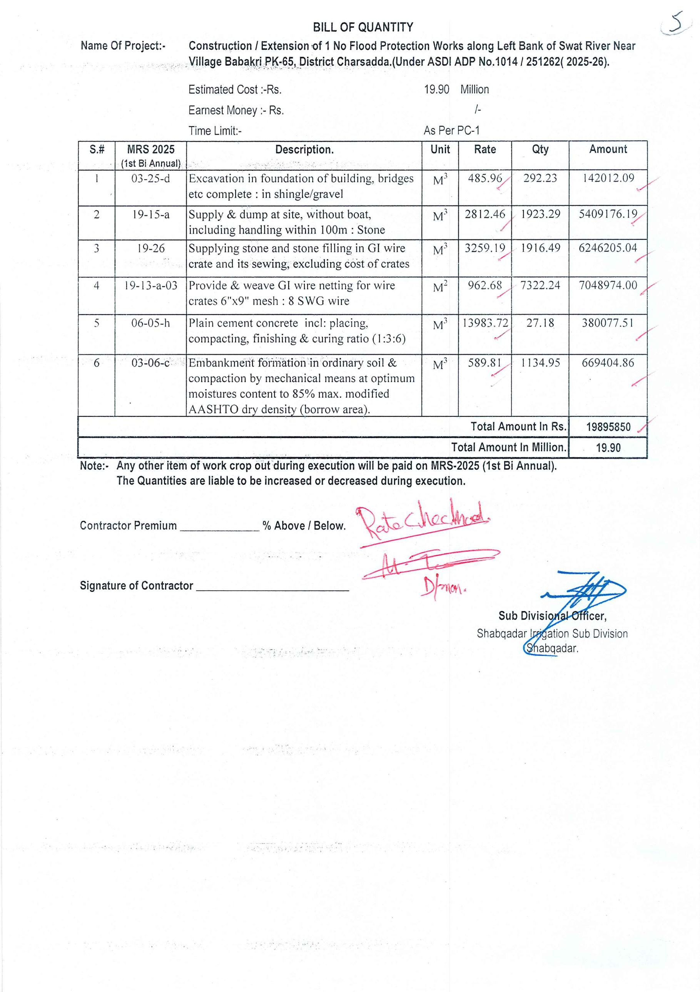

74

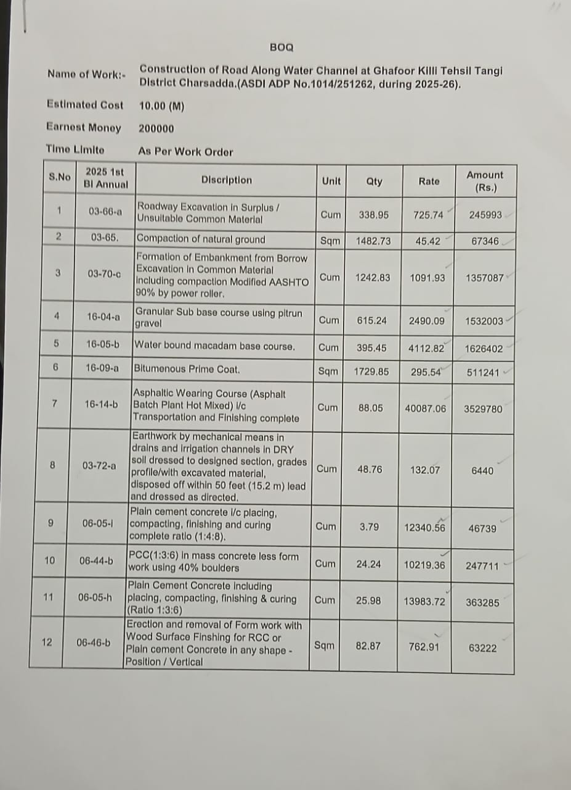

75

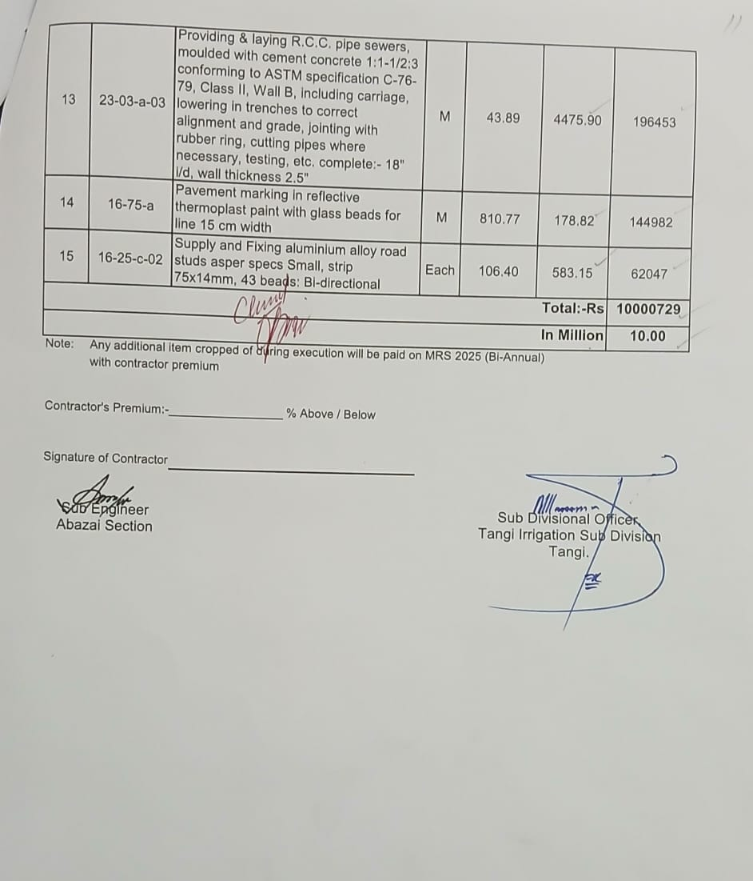

76

